SUBCOURSE EDITION
IT0603 A

US ARMY INTELLIGENCE CENTER

TACTICAL INTERROGATION REPORTS

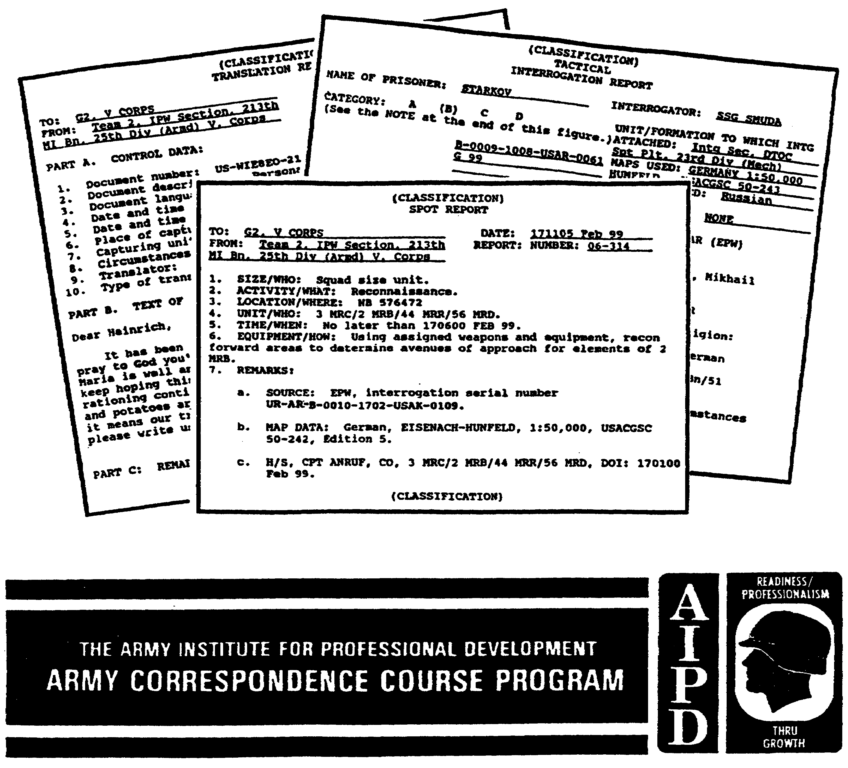
TACTICAL INTERROGATION REPORTS

Subcourse Number IT 0603

EDITION A

U.S. Army Intelligence Center
Fort Huachuca, Arizona 85613-6000

3 Credit Hours

Edition Date: March 1995

SUBCOURSE OVERVIEW

This subcourse is designed to teach the correct preparation of three tactical interrogation reports. The reports are: tactical interrogation, translation, and spot, which are important elements in the interrogation process.

Non MOS 97E personnel should complete USAIC subcourse IT 0606 prior to taking this subcourse.

This subcourse reflects current doctrine at the time of preparation. In your own work situation, always refer to the latest publications.

Unless this publication states otherwise, masculine nouns and pronouns do not refer exclusively to men.

TERMINAL LEARNING OBJECTIVES

ACTION: To correctly prepare the tactical interrogation, translation, and spot reports in such a manner the receiving agency can effectively use the reports' information.

CONDITIONS: Performed in a tactical environment. Given a captured enemy document (CED), document translation, current intelligence requirements, spot reportable information, interrogation notes, and appropriate maps with recorded information.

STANDARDS: To demonstrate competency of this task, you must achieve a minimum of 70% on the subcourse examination.

i IT0603
TABLE OF CONTENTS

Section Page

Subcourse Overview i

Lesson 1: Tactical Interrogation Report (TIR) 1-1

Introduction 1-1

Part A - Report Writing Principles 1-2

Part B - Recording Information 1-3

Part C - Tactical Interrogation Report (TIR) 1-4

Practice Exercise 1-31

Answer Key and Feedback 1-32

Lesson 2: Spot Report 2-1

Introduction 2-1

Part A - Hearsay Information (H/S) 2-4

Part B - Spot Report Preparation Instructions 2-5

Practice Exercise 2-9

Answer Key and Feedback 2-14

IT0603 ii
Lesson 3: Translation Reports 3-1

Introduction 3-1

Part A - Document Exploitation (DOCEX) Section 3-2

Part B - Translations 3-3

Part C - Translation Report Procedures 3-5

Practice Exercise 3-9

Answer Key and Feedback 3-10

Appendix: List of Acronyms A-1

iii IT0603
LESSON 1

TACTICAL INTERROGATION REPORT (TIR)

CRITICAL TASKS: 301-337-1320/2310

OVERVIEW

LESSON DESCRIPTION

In this lesson, you will learn to properly categorize an enemy prisoner of war (EPW) based an his intelligence value. To complete a TIR using correct report writing principles.

TERMINAL LEARNING OBJECTIVE

ACTIONS: Record and report pertinent intelligence information in a correct and readable format.

CONDITIONS: Comprehensive and accurate notes during the interrogation, to include recorded dispositions for accurate TIR preparation.

STANDARDS: Record all interrogation note and map information completely, accurately, and quickly as possible in a correct TIR format.

REFERENCES: The material contained in this lesson was derived from the following publications:

FM 34-52.
STANAG 2033.

INTRODUCTION

An interrogation report is an oral or written statement of information. The reports' purpose is to disseminate information to interested persons or agencies, and to record that information for future reference. The reporting of information using interrogation reports is the interrogator's responsibility. The most critical information the interrogator may obtain is of no value unless it is reported to the appropriate person or agency in a timely manner, and in a usable form. Oral reports are used when it is essential that time sensitive information be reported as soon as possible. The means used for oral dissemination are telephone, radio, and personal liaison. All information disseminated orally should be followed by written reports. Written reports are more complete, and usually are in a particular format (see Figure 1-1).

1-1 IT0603
PART A - REPORT WRITING PRINCIPLES

Every interrogation report should adhere to the following principles--

* Accuracy. Information entered into the report should be exactly as obtained.

* Brevity. The report should be brief, and to the point. All information should be reported. Flowery language or extraneous and unnecessary words should be avoided.

* Clarity takes precedence over brevity. To ensure clarity—

* Use simple sentences, and understandable language.

* Avoid abbreviations, and terms not commonly known.

* Use correct grammar, and punctuation.

* Avoid vague, meaningless, and ambiguous expressions.

* Use topic sentences at the beginning of each paragraph.

* Be specific, do not generalize.

* Coherence. Ideas should be expressed in a logical pattern. Related items should be placed in an orderly sequence.

* Completeness. The report should answer questions anticipated from the reader. Obviously, not every EPW will be able to answer every question completely. There should be a clear indication as to which topics were covered, regardless of the EPWs response. Negative responses to main topics should be recorded to prevent misunderstanding and duplication of effort during further interrogation and report screening.

* Timeliness. Tactical information, in particular, is highly perishable. Because of this, the foregoing principles have to be weighed against the requirement for disseminating information as expeditiously as possible to the appropriate using agencies. An interrogation report should be as complete and accurate as possible, but if it reaches the recipient too late to be acted upon, it is of no value. Therefore, timeliness takes precedence over other principles.

IT0603 1-2
PART B - RECORDING INFORMATION

There are several reasons for recording information obtained during interrogations. The most important of these is to ensure all information can be reported completely and accurately. Recorded information may also be used to--

- Refresh the interrogator's memory on a topic covered earlier, such as returning to a topic after exploiting a hot lead.

- Check responses to repeated questions.

- Point out inconsistencies.

- Gain the cooperation of other EPWs.

- Compare information received from other EPWs.

Taking Notes. The interrogator's own notes are the primary method of recording information. When the interrogator takes his own notes, he has a ready reference to verify responses to repeated questions, or to refresh his memory. They also provide him with the means to record cold leads for later exploitation.

Using his own notes expedites the interrogator's accurate transferal of information into a report format. When taking his own notes, however, he cannot observe the EPW. This may cause him to miss leads, or fail to detect visible losses in rapport or control through clues provided by the EPWs behavior.

It is possible to lose control, and the EPWs willing cooperation, with too much concentration on note taking. The interrogator must avoid distracting the EPW while taking notes. Notes should be taken in such a way that maximum eye-to-eye contact is maintained with the EPW.

The interrogator will not have enough time to record every word the EPW says. He must be able to condense or summarize information into a few words. He must use his past experiences to decide which items of information should be recorded. He should organize his materials to avoid having to flip back-and-forth between references.

1-3 IT0603
The only information that should be recorded during the approach phase is what is required by Part I of the interrogation report (Figure 1-1 and Figure 1-2). All other information should not be recorded until after the EPWs cooperation has been obtained.

All notes must be complete, accurate, and legible. Notes should be organized by topical areas. A separate piece of paper should be used to record cold leads. The interrogator should make maximum use of authorized military abbreviations and brevity codes. Notes should be in recognizable format, and complete enough for any other interrogator to use. Situations may arise that require one interrogator to finish another interrogator's interrogation.

PART C -TACTICAL INTERROGATION REPORT (TIR)

A TIR is a formal record containing the information gained during a tactical interrogation. It is divided into three parts: Administrative Data, EPWs Intelligence Potential (which includes background information, experience, and EPWs knowledge, and Information Obtained (which is the report's text)). Standardization Agreement (STANAG) 2033 outlines the TIR format.

At division echelon and below, time constraints will probably preclude the writing of complete TIRs. Emphasis at these echelons will be placed on interrogating sources for priority intelligence requirements (PIR) /information requirements (IR) information and generating SPOT reports; TIRs will only be completed if circumstances allow. If your unit is operating in an area where STANAGs apply, STANAGs require Part I of the TIR be completed (as a minimum) for each source interrogated.

If possible, each TIR must accomplish the following--

- Answer supported command PIR.

- Eliminate duplication of effort in subsequent EPW interrogations.

- Serve as an assessment of the EPWs credibility, cooperation, intelligence, experience, and specialized knowledge.

- Serve as a guide for future interrogations by including remarks and recommendations for future interrogations.

TIR classification will be done in accordance with (IAW) AR 380-5, and unit standard operating procedures (SOP).

IT0603 1-4
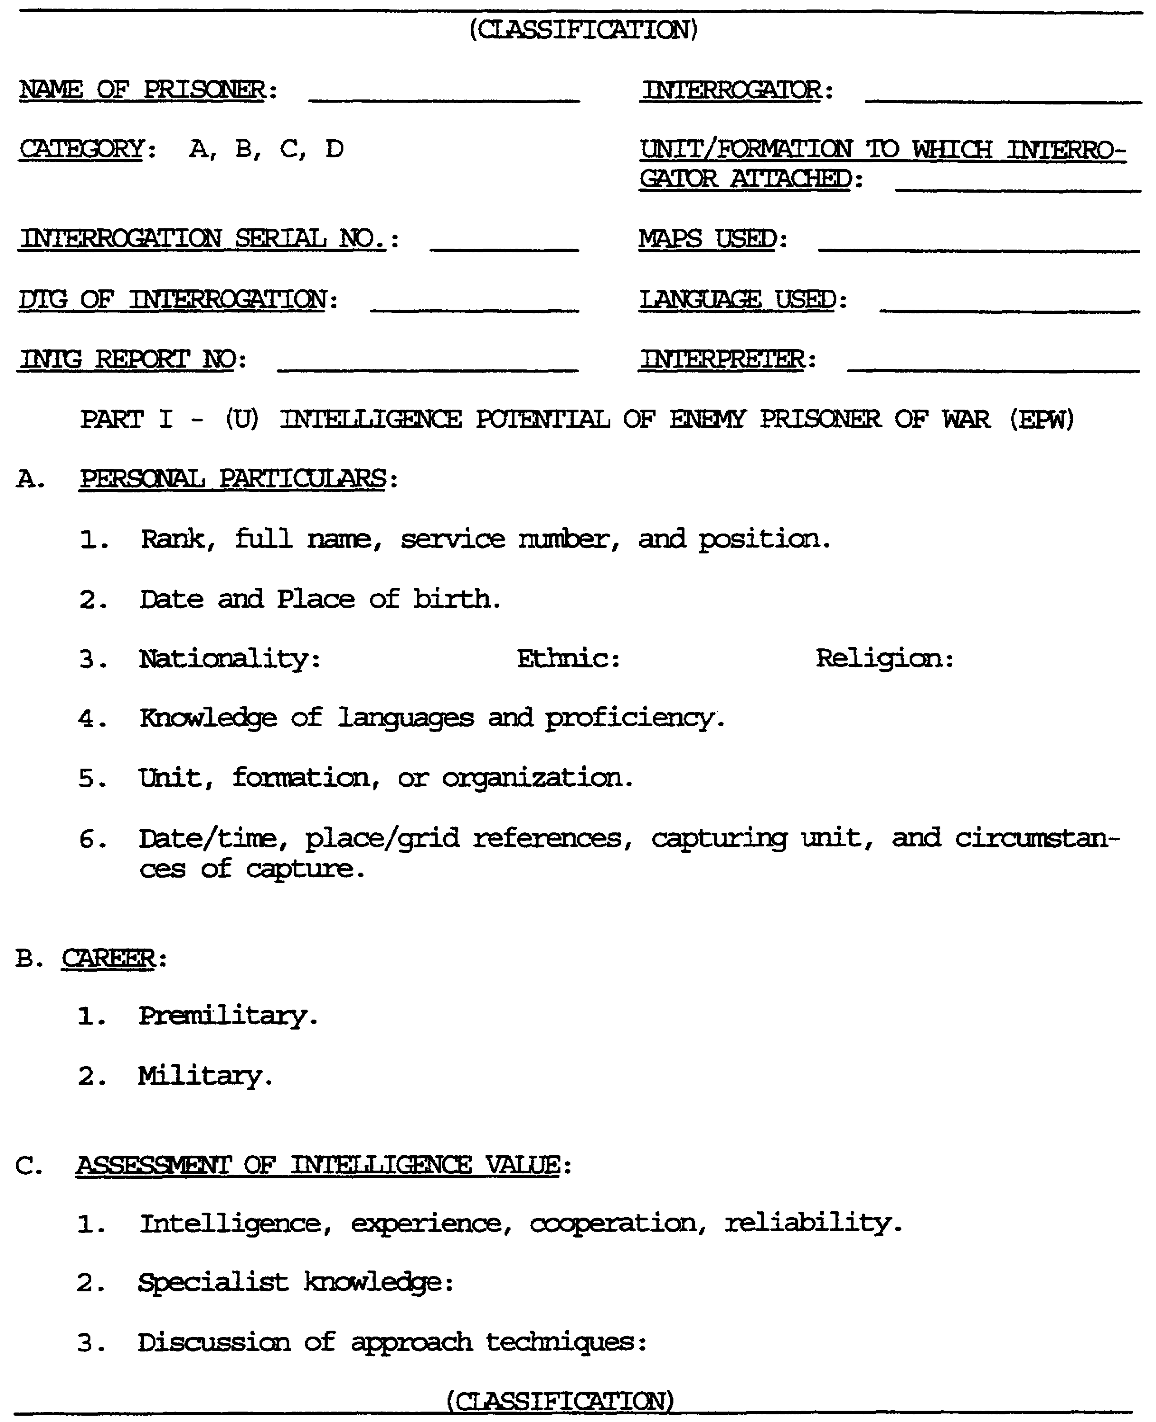

Figure 1-1. PART I, TIR Format.

1-5 IT0603
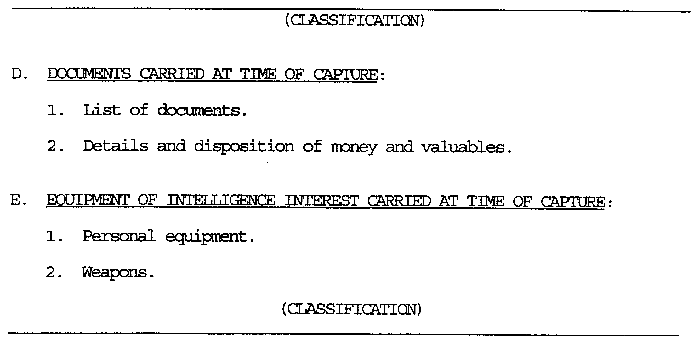

Figure 1-2. PART I, TIR Format (concluded)

ADMINISTRATIVE DATA. Name of prisoner: The EPWs last name is written in CAPITAL letters. Place and country names are also written in CAPITAL letters.

Category: All EPW/detainees will be assigned a category after they have been interrogated, based on their intelligence value. Each category is defined as follows--

Category A: EPW/detainees whose broad or specific knowledge of the total war effort makes it necessary for them to be interrogated without delay by specially qualified interrogators at Corps level. Examples of Category A are: General officers, staff section chiefs at division or higher units, scientific or technical personnel with current knowledge, political officers, nuclear, biological, and chemical (NBC) and psychological warfare personnel, high-ranking civilian officials, war correspondents, personnel in intelligence units or staff positions.

Category B: Those who have information pertaining to the current tactical situation, and PIR, are given this category. Category B will receive a second interrogation at another echelon due to their knowledge.

Category C: EPW/detainees whose knowledge would satisfy only information of immediate tactical value. A second interrogation would not be conducted on a Category C.

Category D: Those who possess no intelligence (military) information.

DTG: Date/Time Group interrogation began.

IT0603 1-6
Interrogation Serial Number: The purpose of the EPW Interrogation Serial Number is to identify the source of information to ensure its proper evaluation, processing and follow-up action. It will also identify the nationality and location of the interrogation unit.

The number shall be constituted as follows:

2 Letters to indicate the NATIONALITY of the PW.

2 Letters to indicate the SERVICE of the PW.

1 Letter to indicate the ARM of SERVICE of the PW.

4 Numbers to indicate the INTERROGATION SEQUENCE NUMBER of the EPW.

4 Numbers to indicate the DAY and MONTH of CAPTURE.

A dash (-) to show a sequence break.

4 Letters to indicate the NATIONALITY and SERVICE of the INTERROGATION UNIT.

4 Numbers to indicate the INTERROGATION UNIT.

Each group shall be separated by a dash. The final number shall therefore appear as in the following examples:

UR - NV - B - 0012 - 2105 - USNV - 0159

Soviet - Naval PW - Seaman - 12th PW interrogated -
Captured 21 May - interrogated by US Navy - team 159.

The following list of letters is to be used to indicate the SERVICE of the PW:

AR - Army NI - Naval Infantry

NV - Navy AR - Airborne Forces.

NA - Naval Air Arm SF - Special Purpose Forces

AF - Air Force PL - Police

IR - Irregular CV - Civilian (other than Police)

Interrogator: Rank and last name of individual who interrogated this EPW. This will be in CAPITAL letters.

Unit/Formation to which Interrogator is Assigned: Interrogator's unit of assignment.

1-7 IT0603
Map Used: This item will reflect the series and sheet names, scale, and edition of map used.

Language Used: State language used during the interrogation.

Interpreter: Indicate whether an interpreter was used during the interrogation. There are only two possible entries for this block: NONE or the rank and last name of the interpreter in CAPITAL letters. See Figure 1-1.

PART I. Part I consists of the EPWs intelligence potential. Reported is the EPWs personal and military background, career experiences, an EPW assessment based upon his performance during the interrogation, as well as items captured with the EPW. Part I is divided into five sections lettered A through E.

Section A will be reported as follows:

- Rank, Full Name, Service Number, and Duty Position: The name will be written in natural order: First, middle, and last name (last name in CAPITAL letters). Service Number will be written: no. SN. Duty position will reflect EPWs current position.

- Date and Place of Birth: List in the following order: The day, month and year of EPWs birth (if the day is 1-9 it will be written 01, 02, 03). This will also include the town in which the MEW was born, the republic state/province and the country, in CAPITAL letters. The second letter of a Soviet Republic may be in lower case, for example, KAZAKH SSR would be written KaSSR.

- Nationality: Include the citizenship, ethnic background, and religion. If the EPW has no religion, report None.

- Knowledge of Languages and Proficiency: List languages known with respective proficiency in each language. The native language is obtained from the screening report. Ask for other known languages with proficiencies during EPW assessment.

- Unit/Formation or Organization: List EPWs full unit designation (FUD) from lowest to highest echelon. The FUD will first be listed by the authorized abbreviated form.

Example of FUD in abbreviated form: 1MRS/2MRP/3MRC/2MRB/69MRR/52MRD.

IT0603 1-8
It is important to remember when reporting any unit organization, indicate where, if at all, a break in unit size or type occurs in an organization. For example, look at the FUD: Chem, Recon Plt/2MRB/69MRR/52MRD, it jumped from platoon to battalion level, and from a chemical unit to a motorized rifle (MR) unit. The break was shown where the change in size and type occurred, that being Chem Recon Plt/2MRB. The brevity for such a unit would be Chem Recon Plt/2MRB/69MRR/52MRD. Here, a break in size and type occurred in the same place. Refer to Figure 1-1.

The following is reported in Section B.

Pre-Military: Here is where pertinent biographical bits of information are recorded. The years of formal civilian education the EPW has had, to include all degrees and in what areas, as well as when he received his degrees. Also included is any vocational training, civilian jobs held, and any paramilitary training the EPW may have had. Report None as an informational response to pertinent questions, where needed.

Military: List number of years EPW has been in the military, and whether he served as a conscript, a volunteer, or both. Also listed here are any military schools EPW may have attended, and any other type of military training besides pre-induction, which has already been reported. Any previous duty positions and units EPW belonged to will be reported here. If the EPW was in any previous units, only reflect that unit in its abbreviated form, not in brevity. Refer to Figure 1-1.

Section C of the TIR is as follows:

Intelligence, Experience, Cooperation, Reliability: This is the report writer's EPW assessment. This information must include the topical words for the heading.

1-9 IT0603
EXAMPLE: EPWs intelligence is rated as average with 10 years of civilian education. His experience is rated as fair with 18 months time in service. EPW seemed cooperative in that he did not hesitate to answer questions. EPW seemed reliable in that no discrepancies were noted thru the use of repeated and control questions.

Specialist Knowledge: List any exceptional knowledge the EPW may have in Political, Scientific, Military, Economic, Sociological, or Psychological areas. If there is none, so state.

Discussion of Approach Techniques: List approaches that did not work as well as those that did. Be specific when reporting approaches used. Refer to Figure 1-1.

Information in Section D of TIR:

List of Documents: List all documents captured with the EPW to include their disposition. The list will include number, description, and disposition of said documents.

Details of Money and Valuables: List all monies and valuables captured with the EPW, and their disposition. Refer to Figure 1-2.

Information in Section E of TIR.

Personal Equipment: This refers to military equipment, such as compasses, binoculars, load carrying equipment (LCE), and so on, not weapons. The equipment is listed in the same format as the items previously, for example, quantity, description, disposition.

Weapons: List any and all weapons captured with the EPW. The list will include number, description, and disposition of said weapon(s). Refer to Figure 1-2.

PART II. Part II begins with SECTION A, Date of Information (DOI). Reflect the DIG of capture. It is important to remember the information to report for all intents and purposes was known to the EPW prior to his capture. Any information reflecting a DIG differing from the time of capture (TOC) will be so indicated. See Figure 1-3.

IT0603 1-10
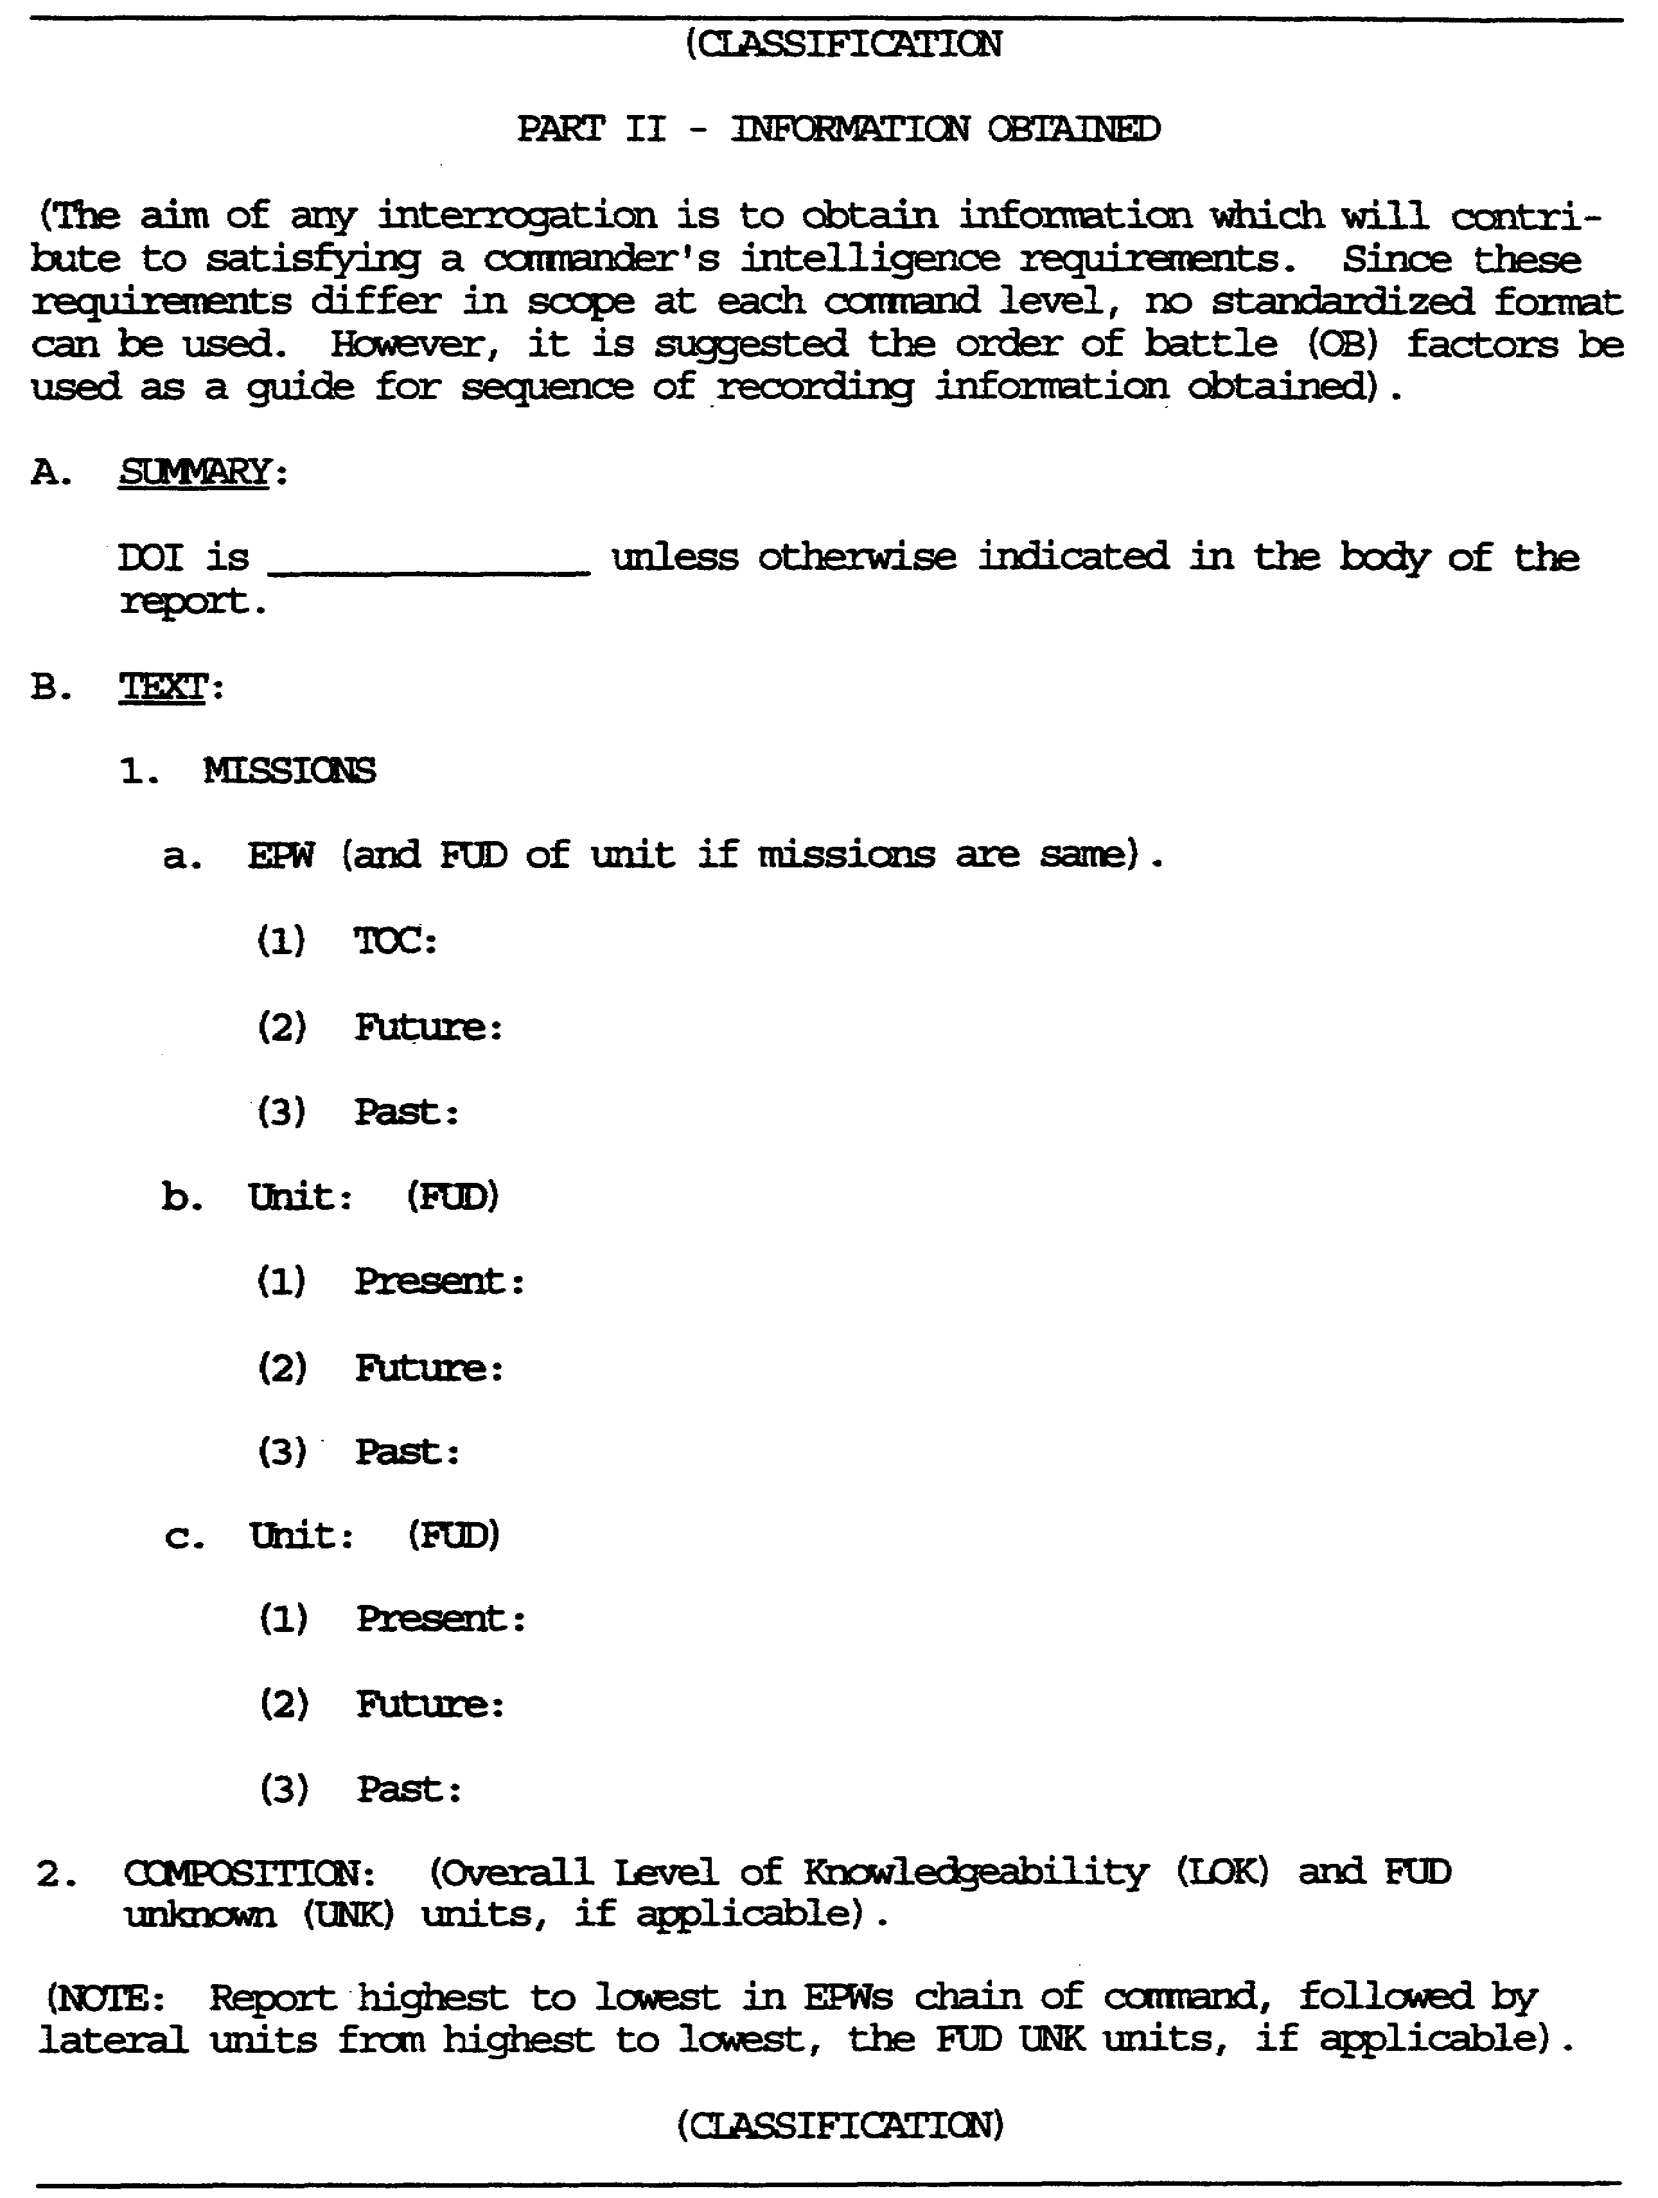

Figure 1-3. PART II, TIR Format.

1-11 IT0603
Section B begins the actual report text. Paragraph format becomes important.

The first paragraph reflects the EPWs missions. Begin by reporting EPWs TOC mission, then Future mission(s), and finally Past mission(s). Report this information just as the EPW described it. Do not omit any information received. Remember the recording and reporting principles.

EPW (by himself) mission(s) will be reported with no tie-ins whatsoever. Everything mentioned will be taken up to division level or as high as EPW knows.

If the EPW and his unit of assignment had the same mission, it would be annotated in the heading of paragraph 1.

After reporting all EPW missions, begin subparagraph b, and report missions of the next echelon in the EPWs chain of command. If all missions of the next echelon are the same or UNK, it is not reflected in the TIR. Begin the next sub-paragraph with the known missions in EIWs chain of command.

When reporting missions of EPWs chain of command, the format will reflect Present, Future, Past. Use TOC for EPW only.

After reporting all missions in the EPWs chain of command, report any known lateral unit missions. Remember lateral unit missions after Strength, however, all missions of which the EPW has knowledge will be reported in Missions. Begin first with all missions in EPWs chain of command, then report from highest to lowest, all lateral missions known to EPW. Refer to Figure 1-3.

In order to establish the composition LOK, begin the Line and Block (L&B) chart specifically with the EPWs chain of command. Determine what echelon, be it division, regiment or battalion, where the EPW began to give information pertinent to the unit's subordination. A minimum of two directly subordinate elements are necessary in order to establish an LOK. An example would be: EPW indicates his division had a HQ element and a MRR subordinate to it. The MRR happens to be the same regiment in EPWs chain of command. The division is going to be the LOK because there are two elements in its subordination: the HQ and MRR. This echelon satisfies the requirement of having two elements in a subordination.

IT0603 1-12
Next to the title Composition, put in parentheses the (LOK).

Once the LOK for Composition has been established, look closely at the LAB chart to see if there are any FUD UNK units whose organizations are known (at least one subordinate unit). If one exists, this will also be incorporated in the LOK. Once this is accomplished, report this under the OB factor. (Example: 52MRD and Engr Bn (FUD UNK)).

Each echelon and its subordination is reported as a separate subparagraph. Whatever the LOK is, it will also be in the first paragraph, for example, if the LOK is 69MRR, paragraph a. will begin: 69MRR had...

The beginning of each sub-paragraph is referred to as a tie-in. Each sub-paragraph must tie-in to the LOK.

The format for each sub-paragraph reported is: Tie-In, command and control element, directly subordinate units, attached units with their FUD, and finally, detached units with their FUD.

To prevent confusion, each sub-paragraph is further broken down as follows: quantity, type of unit, and designation. For example: 69MRR/52MRD had lxRegt HQ, 3xMRB designated dsg 7, 8, 9, 1x122mm How Bn, 1xAttached Tk Plt/2Tk Co/3MRB.

After reporting all organizations in the EPWs chain of command, report subordinations of any lateral units, beginning with the highest echelon, and working through lateral units.

The next items reported in Composition would be any FUD UNK units with known subordination, for example, Engr Bn (FUD UNK) had 1xEngr Co, dsg UNK.

The last items reported would be FUD UNK units with UNK subordination, for example, EPW also knew of lxMed Co (FUD UNK). Refer to Figure 1-3.

Each paragraph reported in Composition must begin first with a tie-in. Also remember the brevity code introduced earlier in the report.

1-13 IT0603
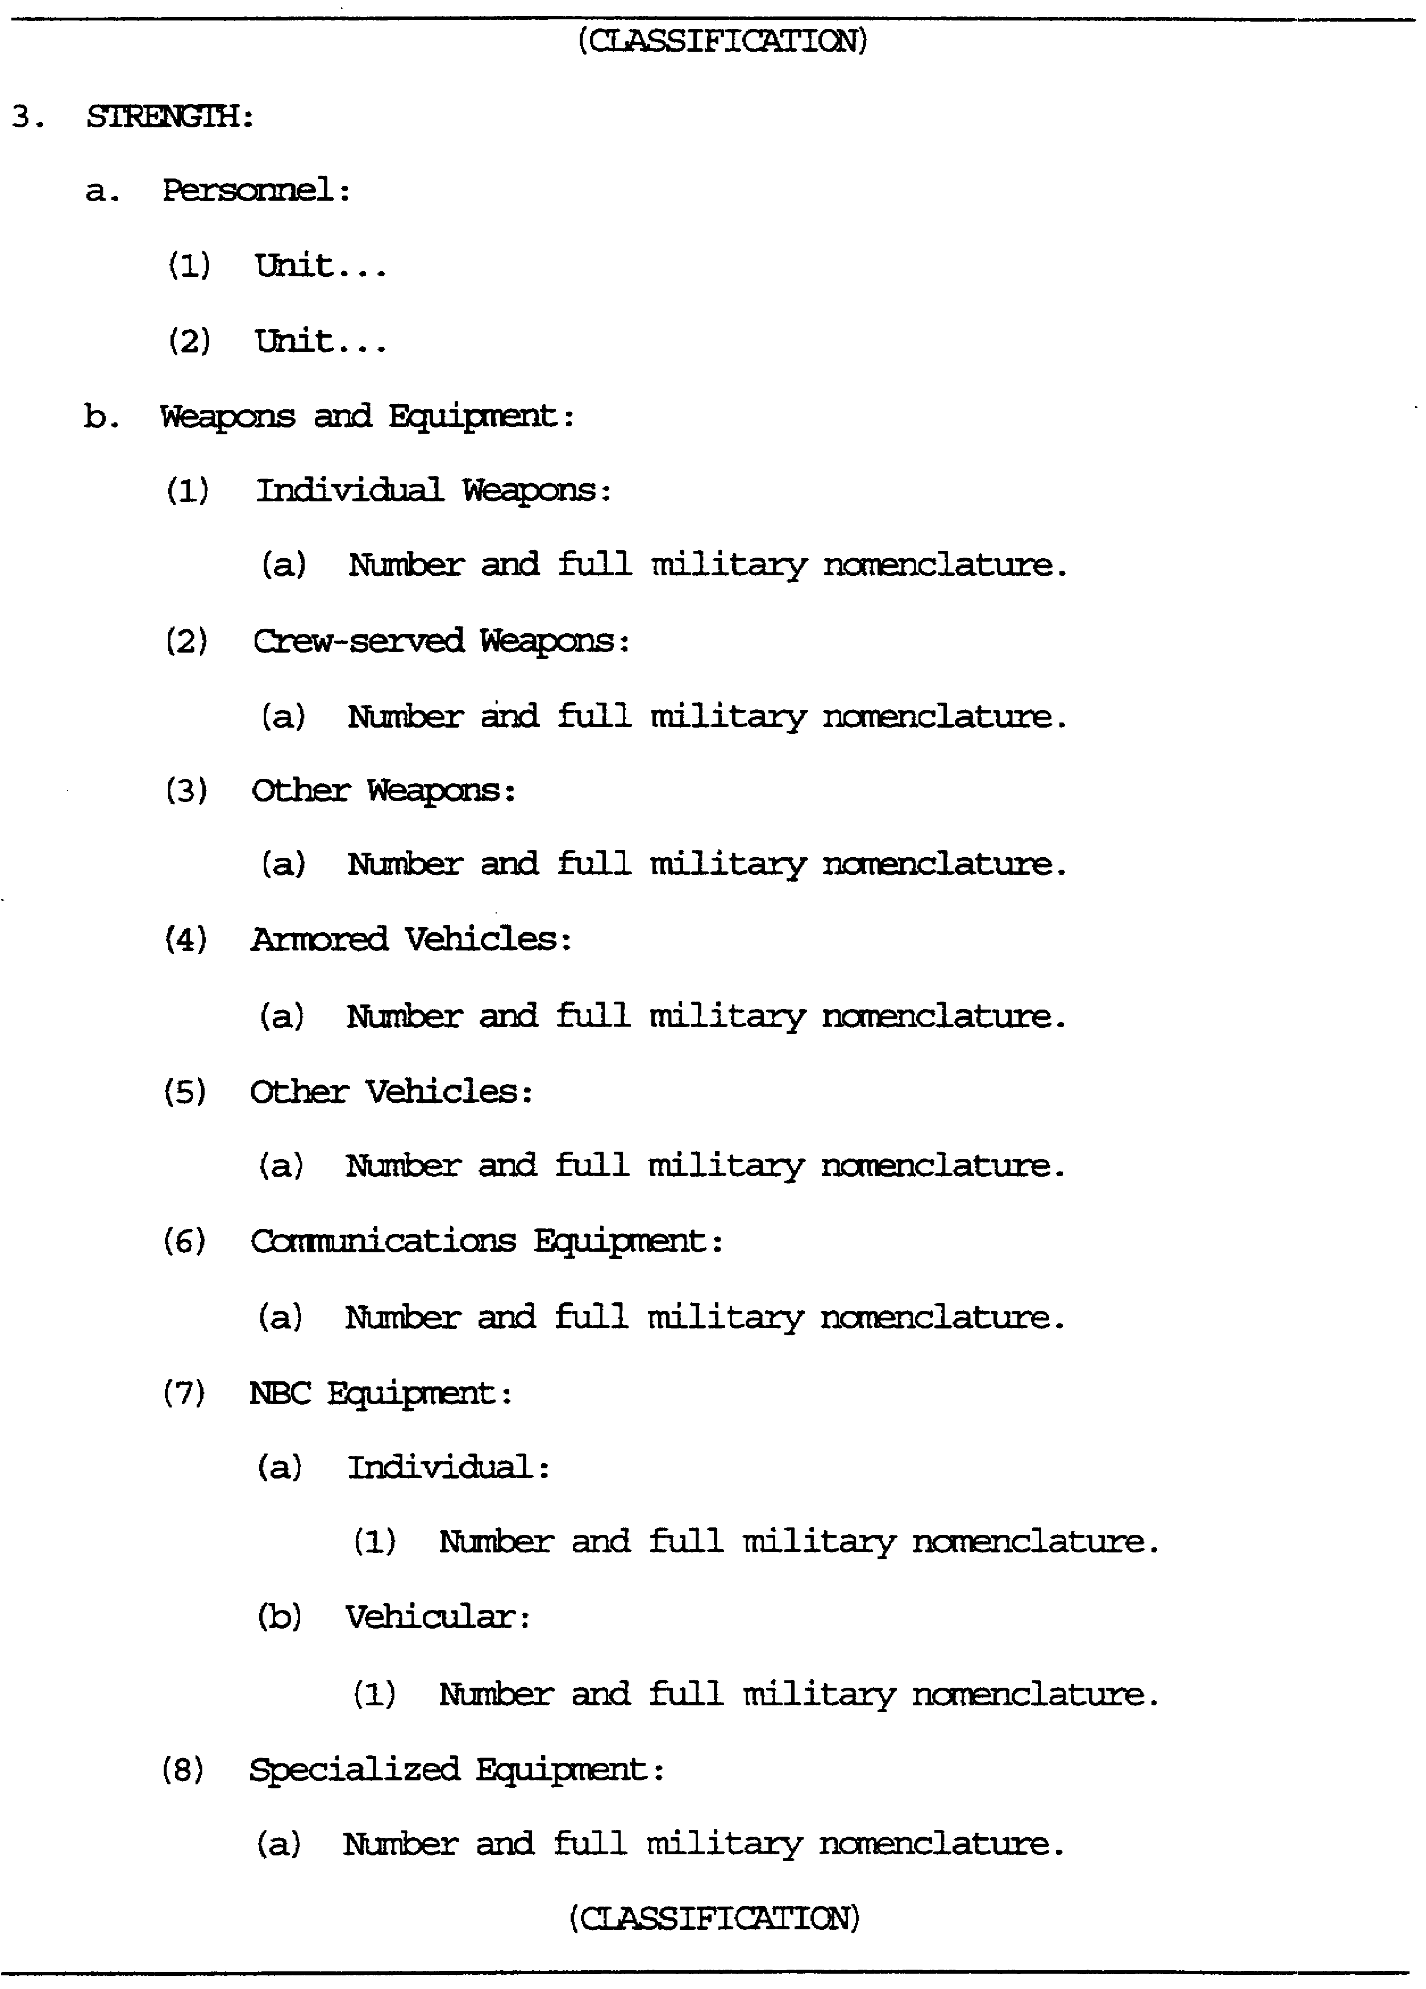

Figure 1-4. Strength section of PART II, TIR Format.

IT0603 1-14
The paragraph format will be the same, but the content will differ. The format for reporting personnel strength will be: Tie-in to LOK, echelon total personnel strength (TPS), then a officer/enlisted (OFF/EM) breakdown.

If a HQ element is known, then after reporting the major unit, report its HQ with OFF/EM breakdown. However, at this point, reflect the duty positions of the OFF/EM.

Strength (LOK, the higher between Personnel, Weapons and Equipment).

A. Personnel (2MRB).
1. 2MRB had 450xpers (35xOFF/415xEM)
2. HQ, 2MRB had 6xpers (3xOFF-CO, PO, TO/3xEM-Bn SGM, BTR dvr, BTR Gnr) .

Only report those duty positions at Company level and lower. Report duty positions of HQ elements of Battalion level and lower. If the EPW belongs to a HQ element at Regiment or higher, there will be many duty positions/staff sections.

The order of reporting TPS is the same as Composition. Report from highest to lowest echelon in the EPWs FUD, then any TPS known for lateral units from highest to lowest, and finally FUD LU units if known.

If there is no HQ element at Platoon level, when reporting Platoon TPS, show officer duty positions, and duty positions of the senior ranking EM. If a platoon HQ exists, report at platoon level: TPS, Number OFF/EM. At platoon HQ, show TPS number and duty positions of OFF/EM.

When reporting squad level, report TPS x EM, and all squad member duty positions. Remember to report duty positions obtained for HQ elements (Battalion and lower), Company level down, squads, sections, teams and duty positions of OFF/Senior ranking EM if no platoon HQ is reported.

In sub-paragraph b. report Weapons and Equipment (Wpns/Equip).

To find the LOK for this sub-paragraph, look through all sub-paragraphs under Wpns/Equip and determine LOK from the highest informational response received in this area.

This area will be reported in eight different sections as there are eight different sub-sections for Wpns and Equip.

Report the individual sub-paragraph in the order questioned during the interrogation, beginning with Individual Weapons.

1-15 IT0603
The LOK for each sub-paragraph will tie-in to the LOK for Wpns/Equip Strength.

The format for reporting each item under Wpns/Equip strength is as follows: Total number x full military nomenclature (FMN), distribution, with the distribution (in parentheses) tying-in to the LOK for the particular sub-paragraph.

When reporting Armored Vehicles: Total number x FMN, each armed with number x FMN of the armament, and vehicle distribution.

When reporting NBC, keep in mind it is reported in two sub-paragraphs, individual and vehicular. The LOK for each of the sub-paragraphs must tie-in to the LOK for NBC. (This is one of the authorized abbreviated headings). Refer to Figure 1-4.

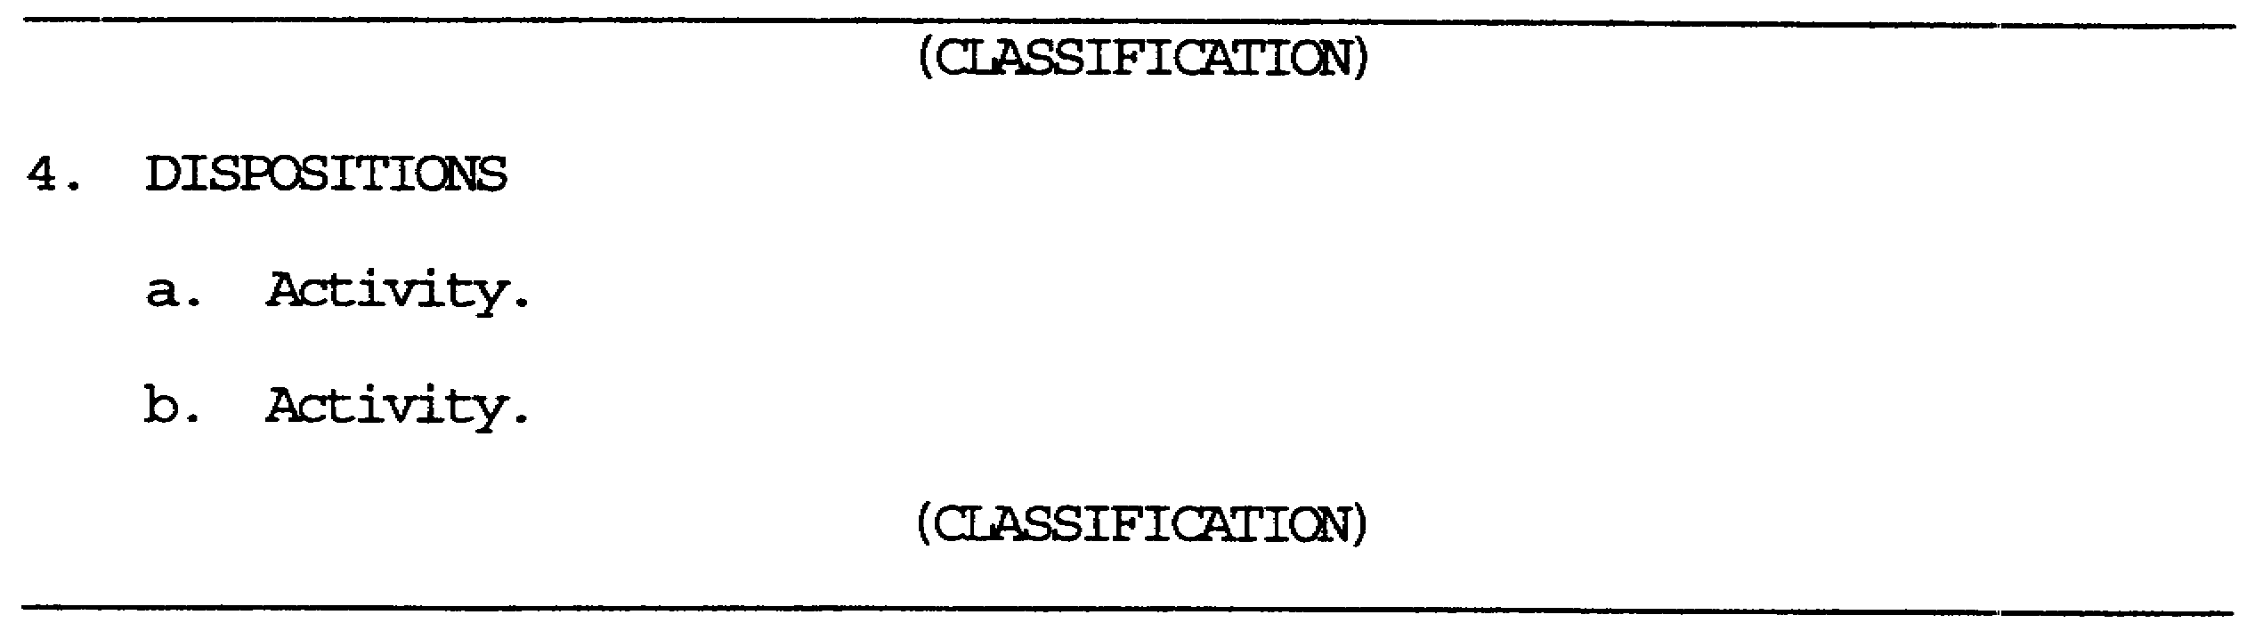

Figure 1-5. Disposition section of PART II, TIR Format.

The next order of battle (OB) factor to be reported is Dispositions.

Dispositions will not have an LOK. There is no particular order in which dispositions, as a whole, must be reported.

Each Disposition is reported in lettered sub-paragraph, in a narrative format. The format will be: Activity, FUD, six-digit location (grid) coordinate, a geographical description of location, colocated units, security measures, and DOI or hearsay (H/S), if appropriate. Colocated units and security measures will always be reported even if "None" or "Unknown". See Figure 1-5.

IT0603 1-16
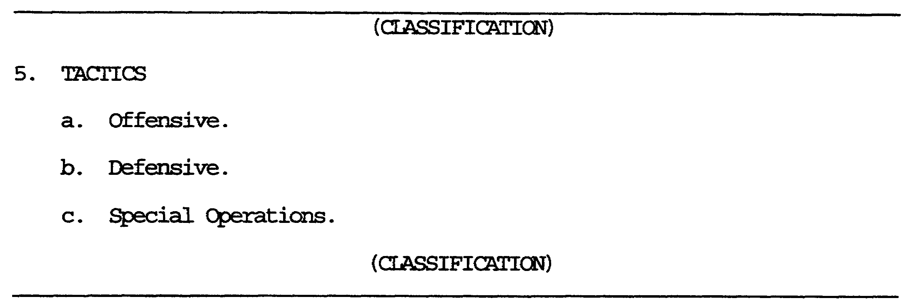

Figure 1-6. Tactics section of PART II, TIR Format.

Tactics will have an LOK.

If EPWs had no knowledge of tactics, there would be no LOK. Still enter the paragraph heading and indicate an UNK response next to it.

Tactics will be reported in lettered sub-paragraph format beginning with offensive tactics. Each type of tactic known will have an LOK tying-in the LOK for Tactics, and be reported in narrative form. If the EPW only knew one tactic, sub-paragraph will reflect all three topics. Report the appropriate sub-category of tactics (with LOK) of which the EPW had knowledge. Next to the remaining tactics report either UNK, None, or Did Not Ask (DI). See Figure 1-6.

1-17 IT0603
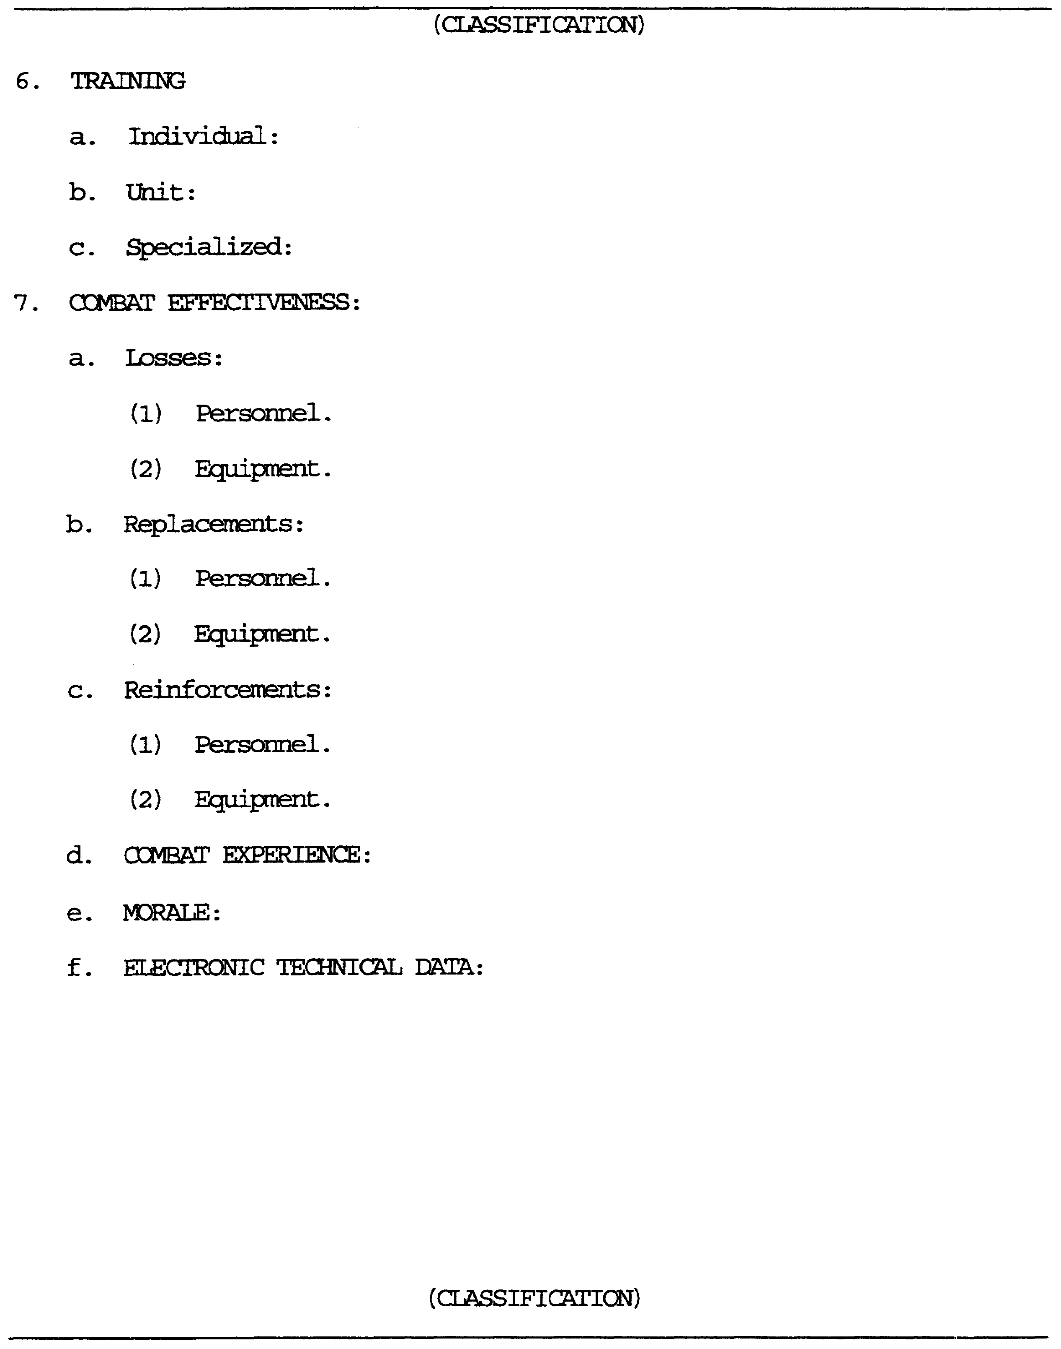

Figure 1-7. Training and combat effectiveness sections of
PART II, TIR Format.

IT0603 1-18
The sixth main paragraph is Training. This will be reported with all three sub-headings and a narrative response next to each sub-paragraph. If EPW knew of no training at all, an UNK will take the place of the LOK. However, if EPW had knowledge of at least one type of training, report that training, and next to the other sub-paragraph report UNK/DNA/NONE as appropriate. See Figure 1-7.

The seventh paragraph is Combat Effectiveness (CE), the sixth OB Factor.

This item will have five sub-paragraphs. CE will have an LOK and each sub-paragraph like always, must tie-in to it.

Losses are divided into two sub-paragraphs, Personnel and Equipment, each with an LOK tying-in. Report in narrative format any information about losses under the appropriate sub-paragraph. The same for Replacements and Reinforcements, to include all LOKs. If the EPW had no knowledge in this OB factor, an UNK will take the place of the LOK. If the EPW had knowledge of at least one sub-paragraph, include all sub-paragraphs. However, next to the particular sub-paragraph, write UNK/DNA/NONE as appropriate. NOTE: Losses, replacements, reinforcements, personnel and equipment can be combined if they have the same information.

ELECTRONIC TECHNICAL DATA

This would normally be collected at echelons above corps (EAC), however, it could be uncovered at division level. Electronic technical data is required to conduct electronic warfare (EW). This includes enemy communications and noncommunications equipment parameters, for example, emitter type and nomenclature (to include encoding equipment), frequency modulation (FM), multiplex capability, pulse duration and repetition frequency, bandwidth, associated weapon systems, and other technical enemy electronic emissions characteristics. Also included are critical enemy communication nodes and support electronic order of battle (EOB) templating.

With electronic technical data, a more accurate enemy electronic countermeasures (EC) vulnerability evaluation can be made. Signal intercept and direction finding (DF) for signals intelligence (SIGINT) production is made easier. Support is given to electronic counter-countermeasures (ECCM) by assessing the enemy EW threat. See Figure 1-7.

1-19 IT0603
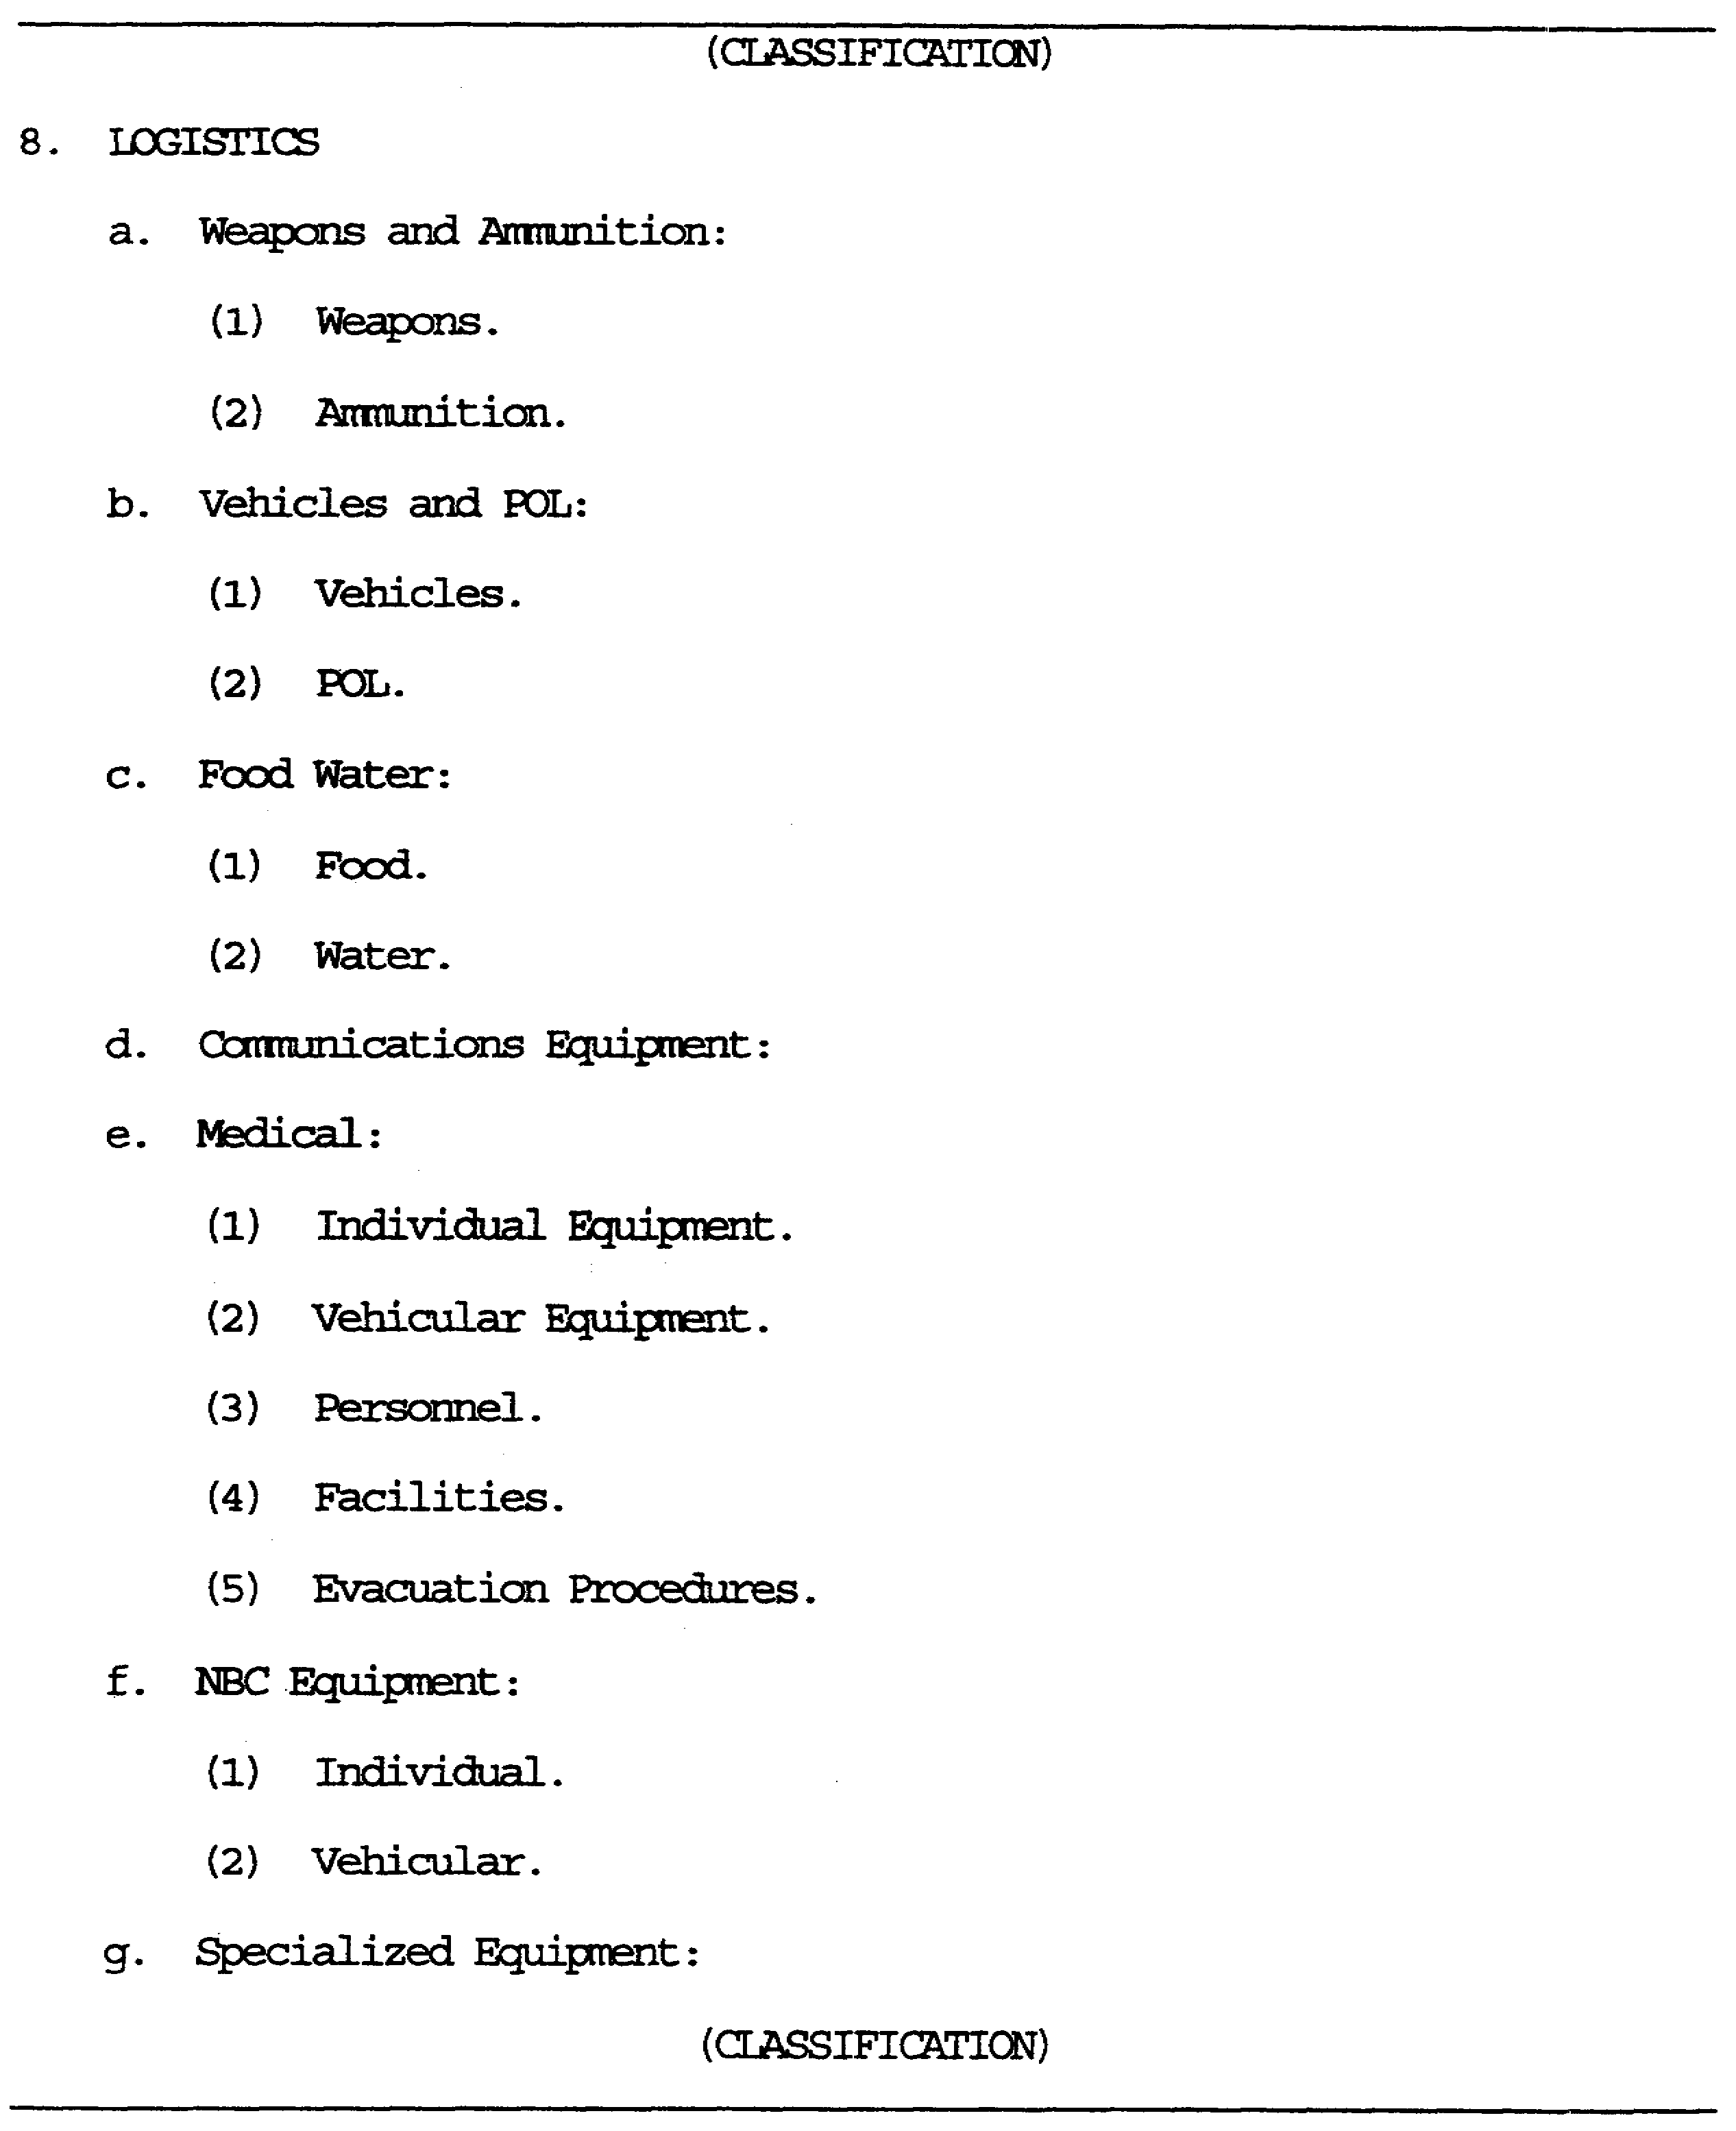

Figure 1-8. Logistics section of PART II, TIR Format.

IT0603 1-20
Paragraph 8, the seventh OB factor, Logistics, is reported next.

Report the condition of all items noted under Wpns/Equip (Para 3b). Logistics will have an LOK; and the LOK for each sub-paragraph under Logistics will tie-in to the LOK for Logistics. There are six in sub-paragraphs Logistics, and each sub-paragraph will be reported in a narrative format.

Weapons (Wpns) and ammunition (Ammo) will be reported first under their appropriate sub-headings, those being Wpns and Ammo respectively. Each sub-heading will require an LOK to tie-in to Wpns and Ammo. NOTE: Specialized equipment, sub-paragraph g, is reported only if there is information in paragraph 8 under Wpns/Equip.

Each sub-paragraph will be reported in the same format as for Wpns and Ammo: sub-paragraph with tie-in, sub-heading with tie-in, and then the narrative.

Communications Equipment, because it has no sub-headings, will have only an LOK with the narrative after.

Report all sub-headings under medical with respective tie-ins leaving out no sub-headings unless all of medical is UNK. If that is the case, UNK will replace the LOK. Refer Figure 1-8.

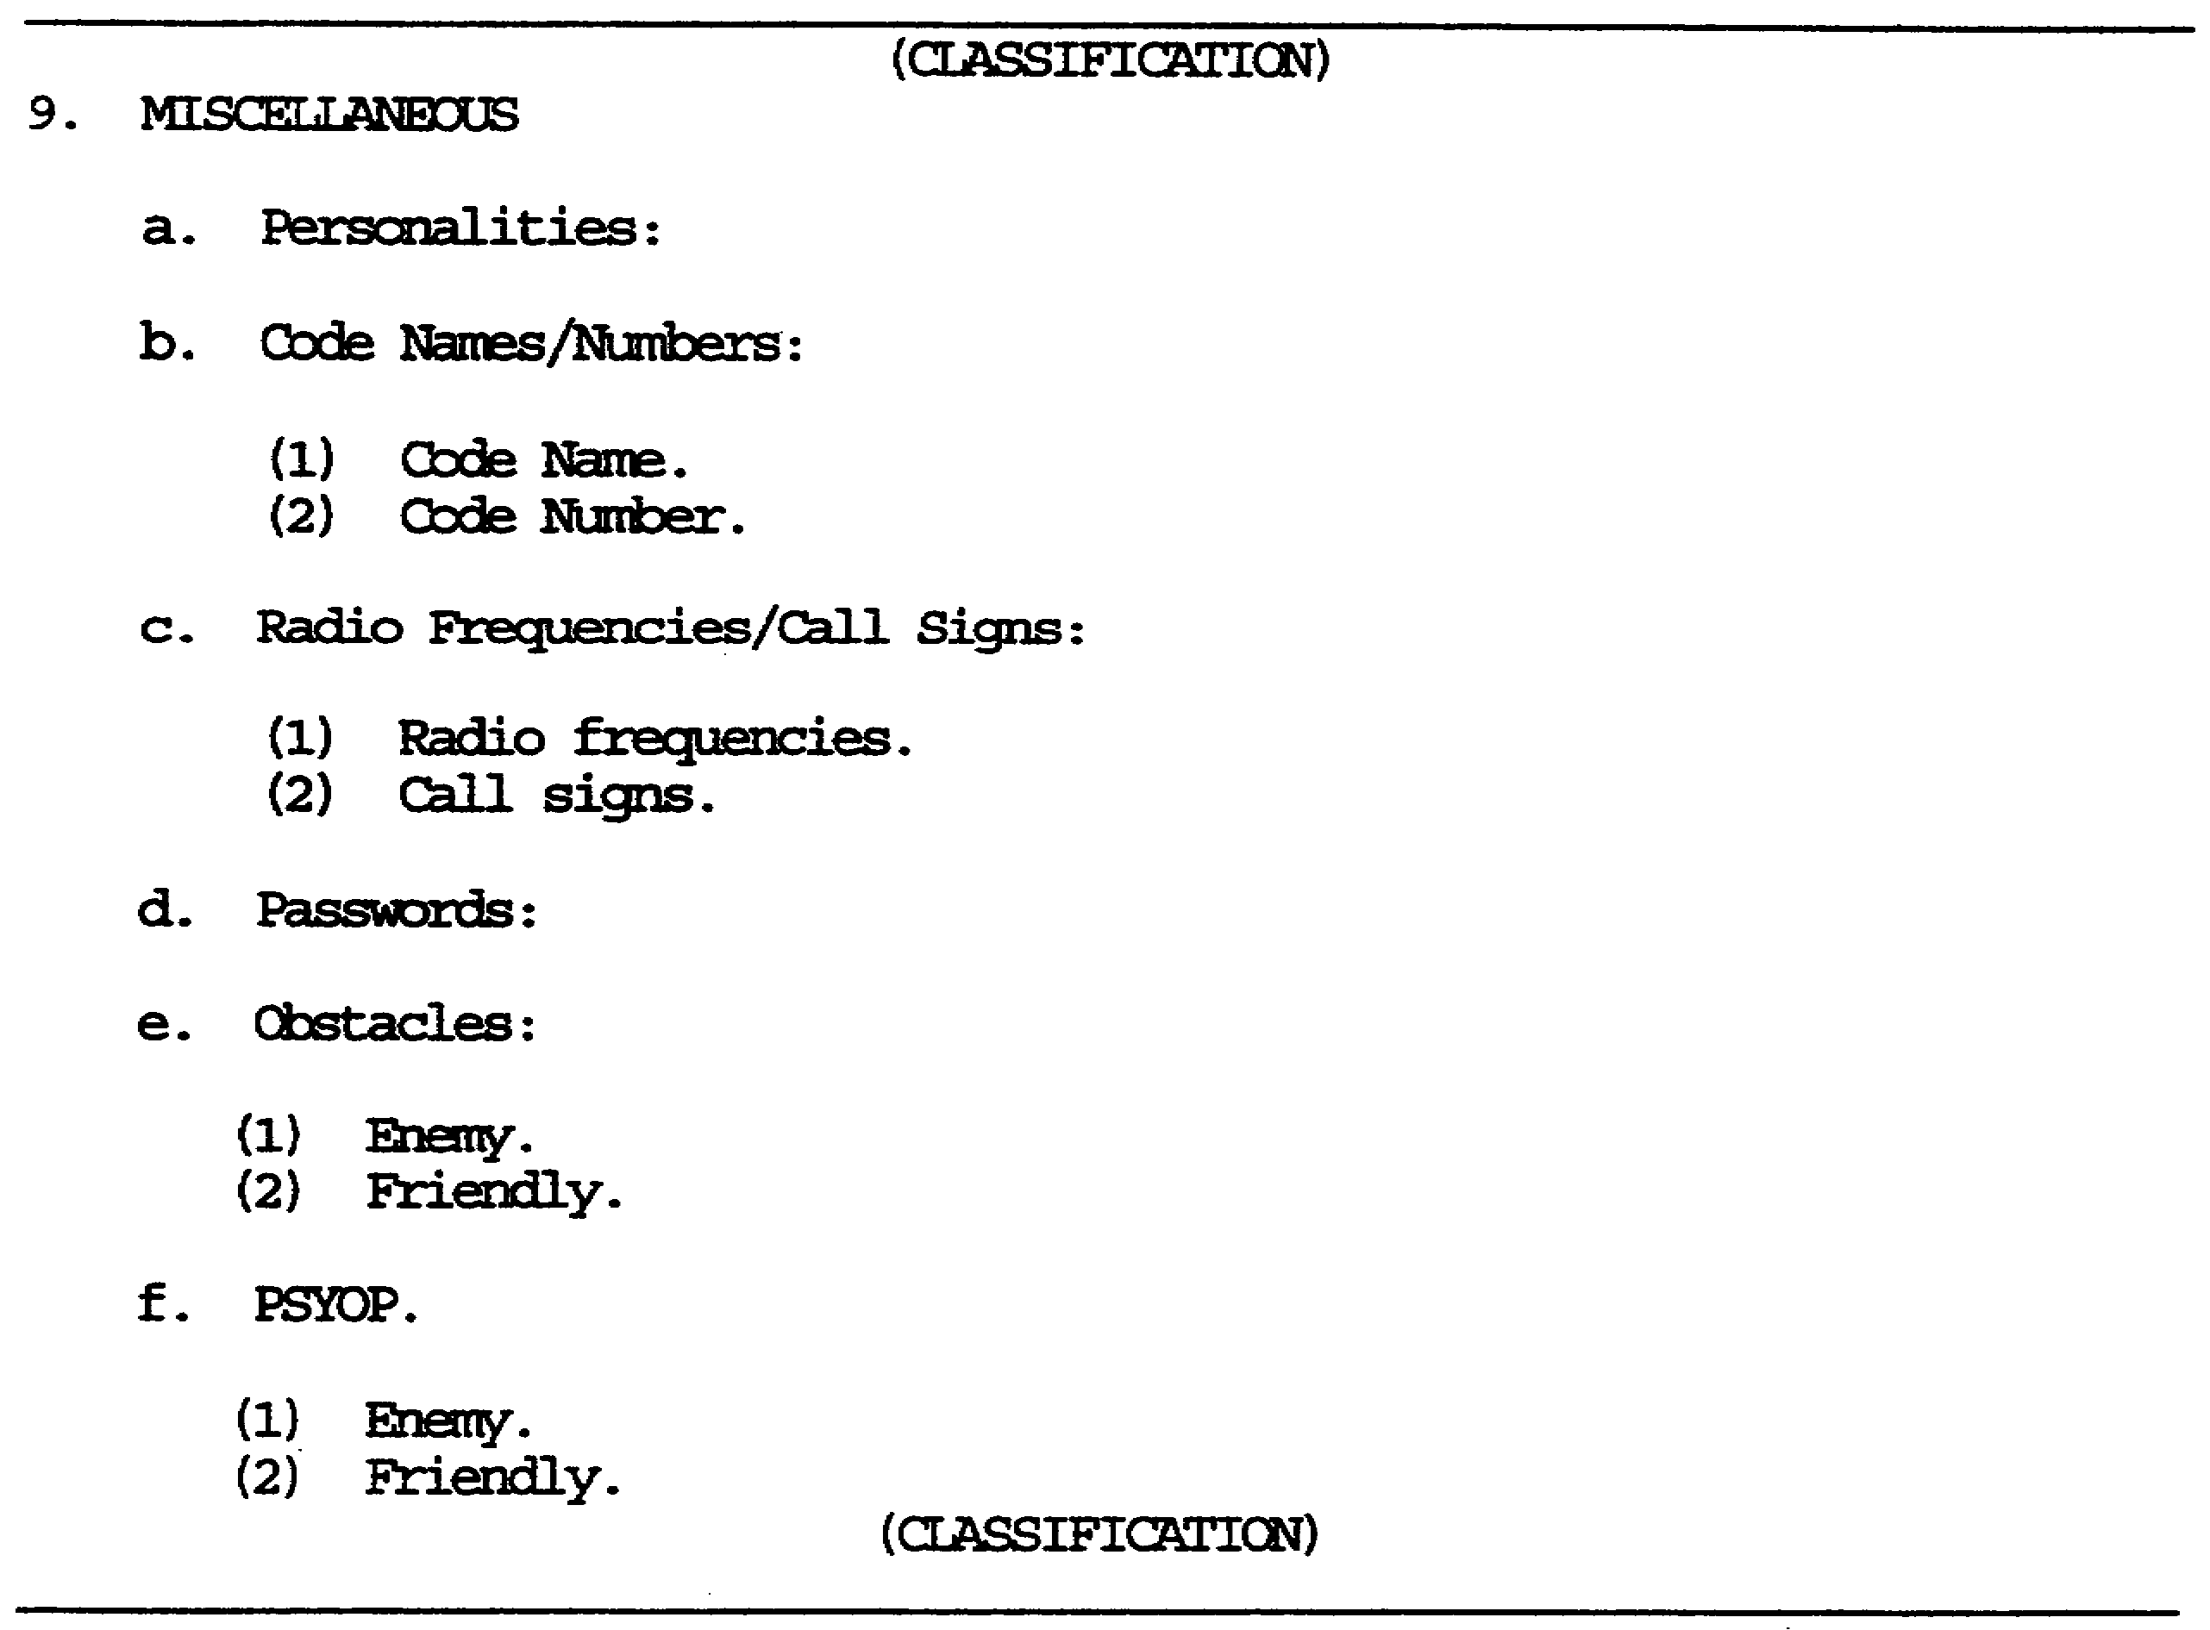

Figure 1-9. Miscellaneous section of PART II, TIR Format.

1-21 IT0603
The ninth paragraph, eighth OB factor, Miscellaneous (Misc), is the last item to be reported.

Misc also has an LOK, each sub-paragraph will tie-in to the LOK for Misc.

The first sub-paragraph reported is Personalities. Report all personalities obtained from battalion or higher of MRR units, company and above for other type units with Last, First, and Middle names, followed by rank, position and finally FUD, with FUD tying-in to LOK for Personalities. Individual personalities will be listed from highest to lowest echelon. If commanding officer (CO), political officer (PO), and technical officer (TO) from one unit are known, the order reported will be CO, PO, then TO. If first name or initial is UNK, write first name UNK (FNU). If middle name or initial is UNK, write middle name UNK (MNU). The following chart will be written:

LAST NAME FIRST NAME MN/I RANK PSN FUD.

The next paragraph is Code Names/Numbers. This paragraph will have two sub-paragraphs reflecting the topic being reported. Both sub-paragraphs will have LOKs tying-in to the LOK for Code Names/Numbers.

Next is Radio Frequencies/Call signs. This paragraph has an LOK, which ties-in to the LOK for Misc. Both sub-paragraphs have LOKs which tie-in to the Radio Frequencies/Call signs LOK.

Radio frequencies will be listed in the following order: Radio, Primary then Alternate frequencies. After listing all known frequencies, report when frequencies are in effect, when changed, and authority for the change.

Call signs will be listed in the following order: Unit, Primary, and Alternate. After listing all known call signs, report when they are? in effect, when changed, and authority for that change.

Passwords is the next written entry. It will have an LOK tying-in to the LOK for Misc, then report challenge and countersign for the password.Again, report when in effect, when changed, and authority for change.

The last two items to be reported are Obstacles and Psychological Operations (PSYOP). Report under each of these, sub-paragraph reflecting ENEMY and Friendly LOK is last enemy unit encountered. Refer to Figure 1-9. Figure 1-10 thru 1-17 show a sample of a completed TIR.

IT0603 1-22
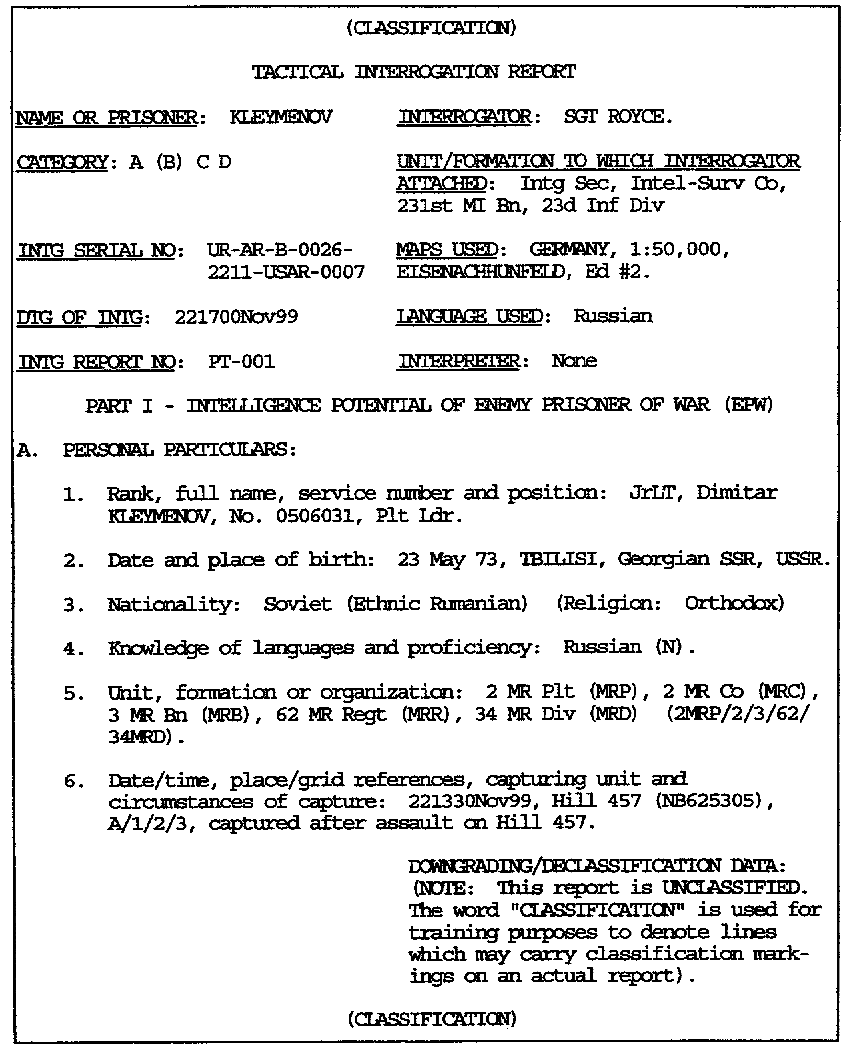

Figure 1-10. Sample of Completed Tactical Interrogation Report.

1-23 IT0603
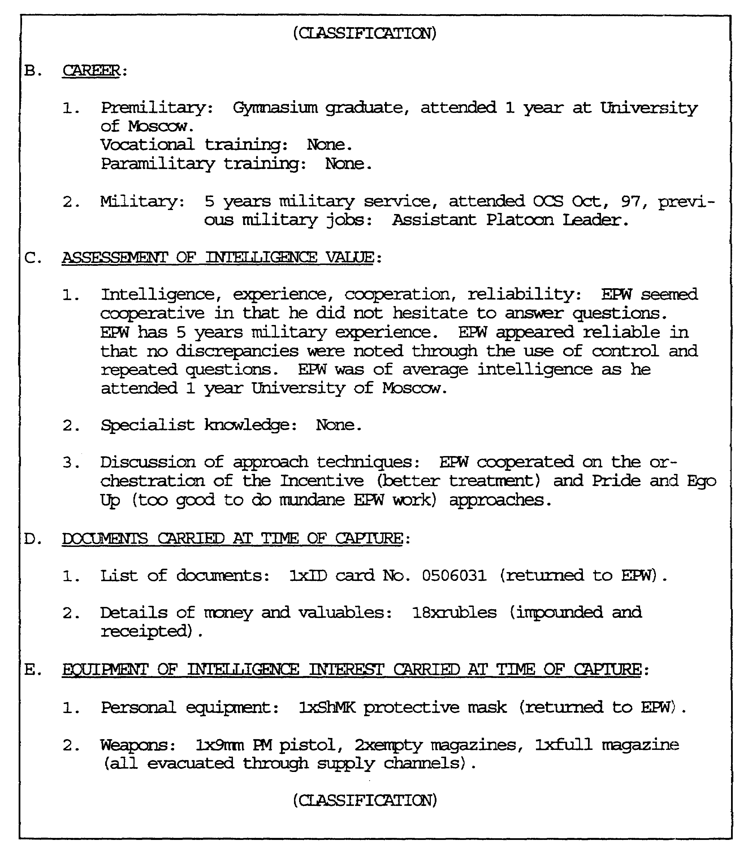

Figure 1-11 (continued).

IT0603 1-24

Figure 1-12 (continued).

1-25 IT0603
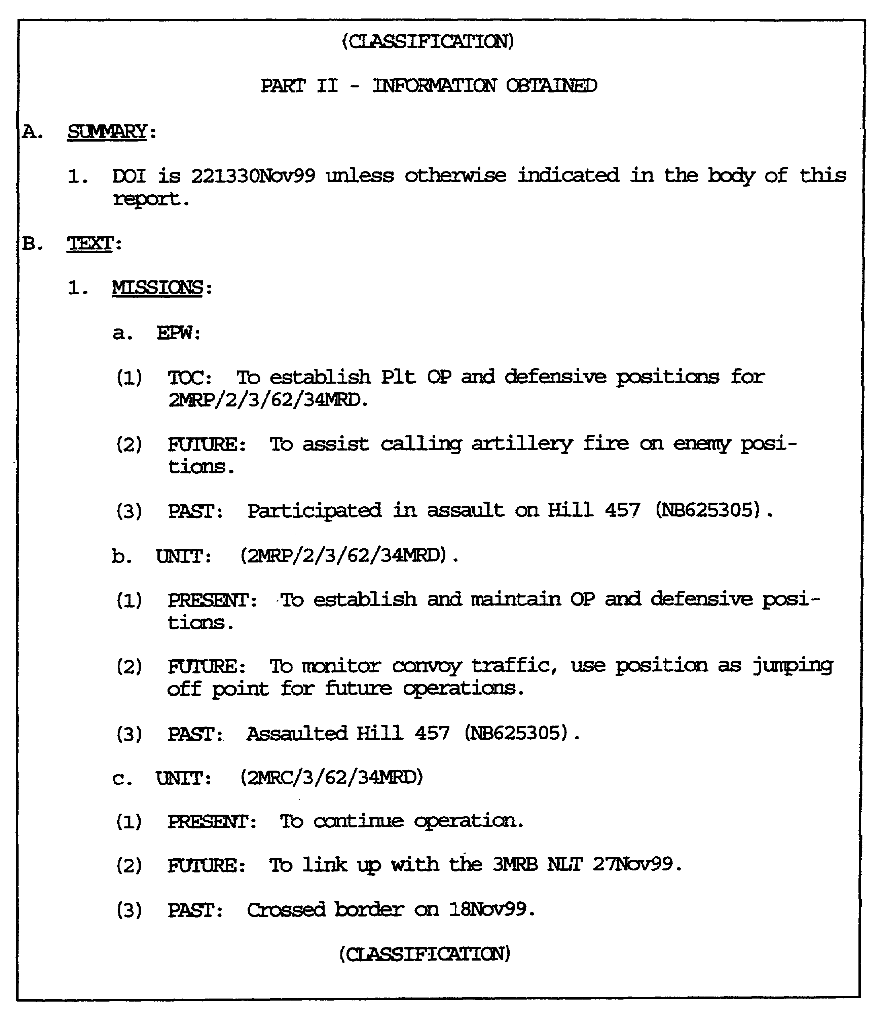

Figure 1-13 (continued).

IT0603 1-26
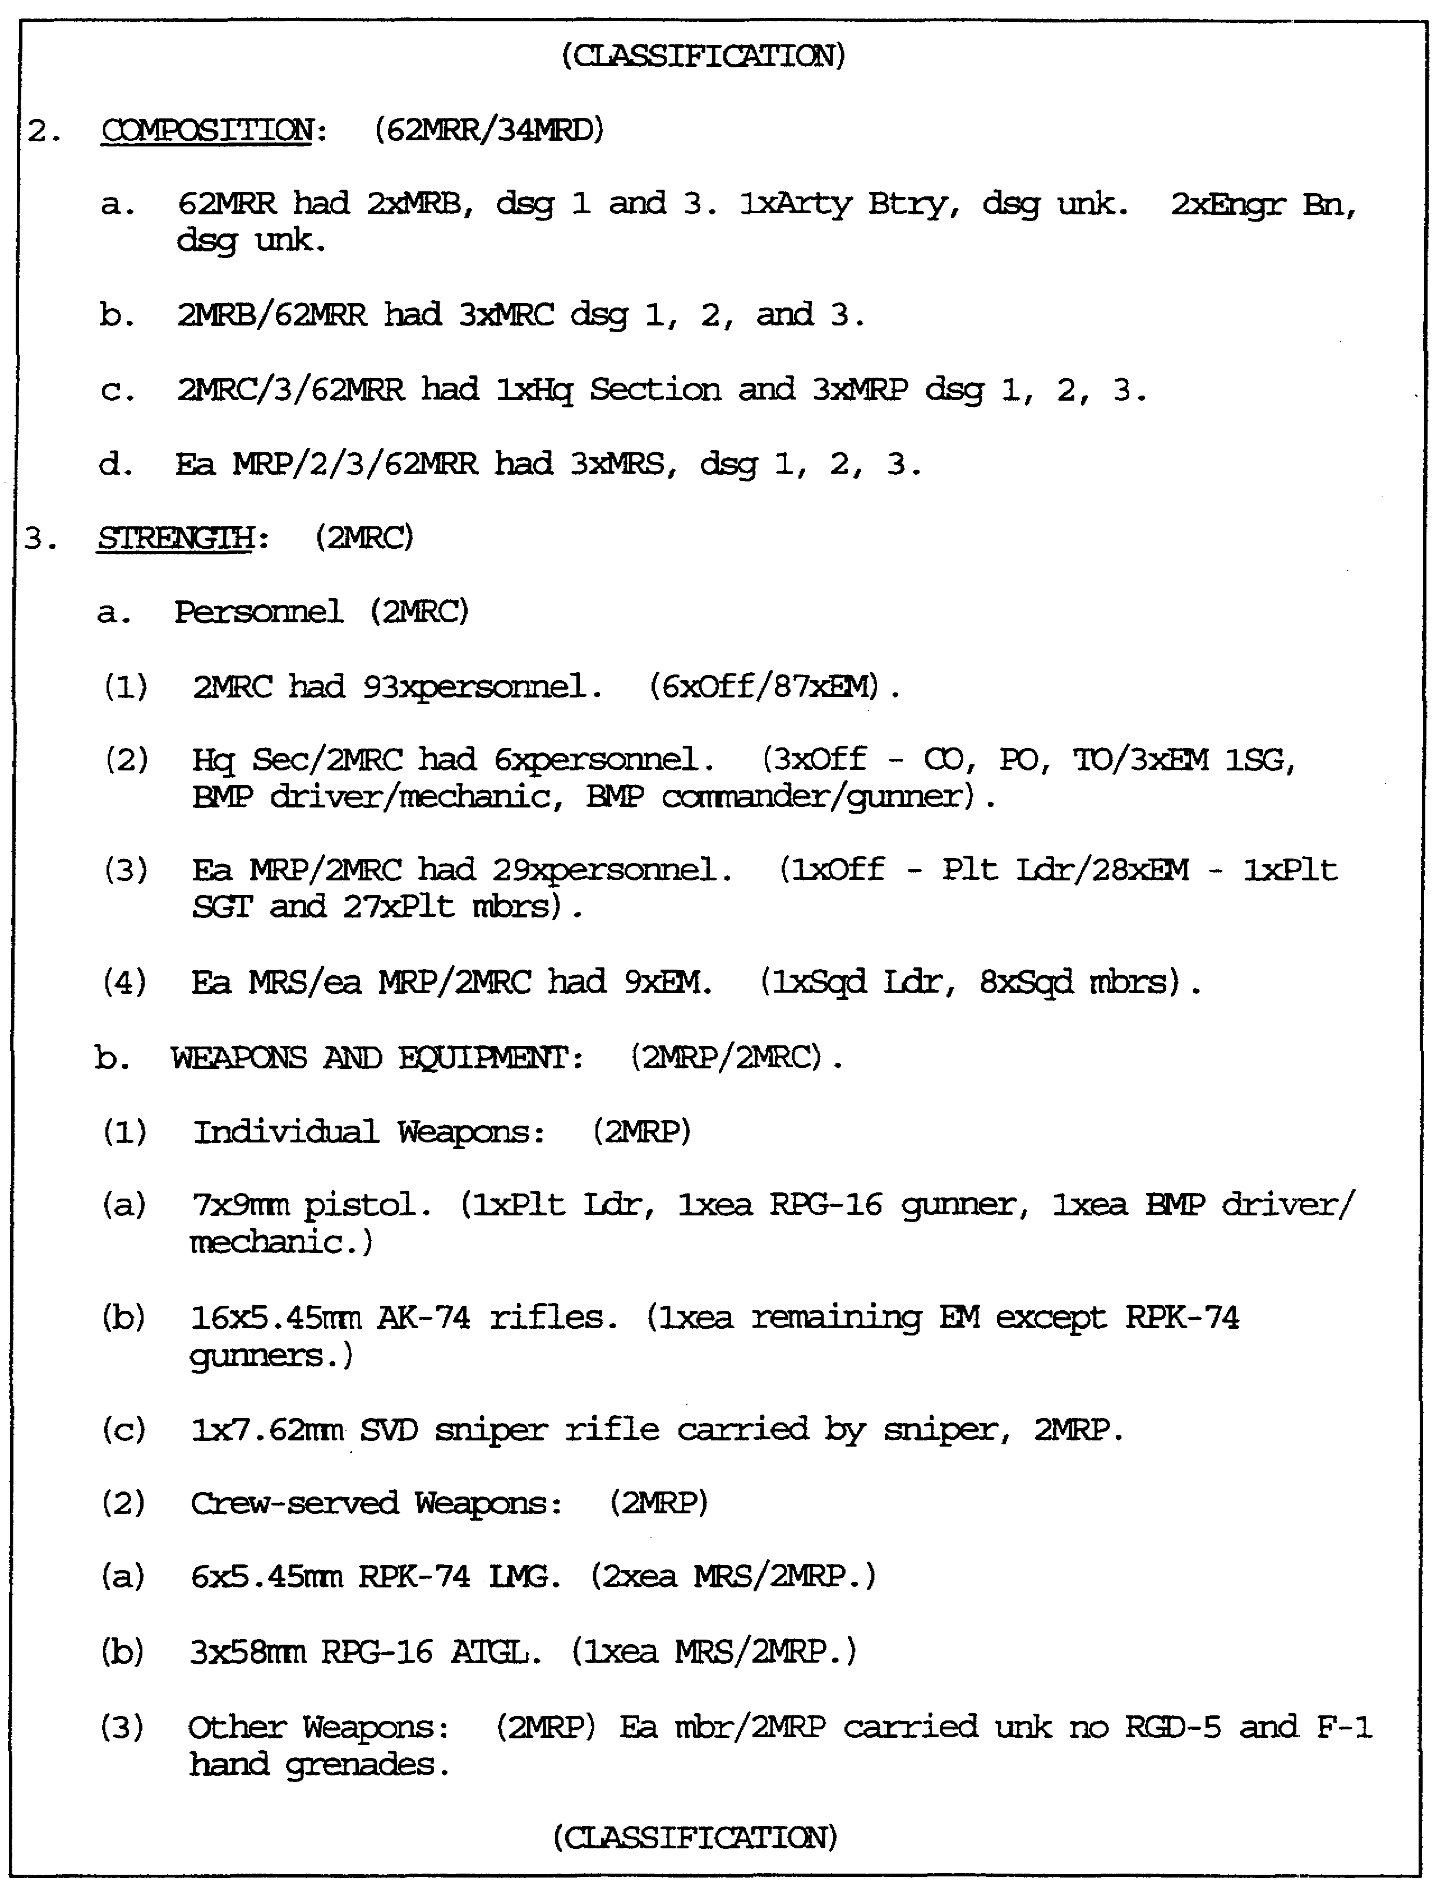

Figure 1-14 (continued).

1-27 IT0603
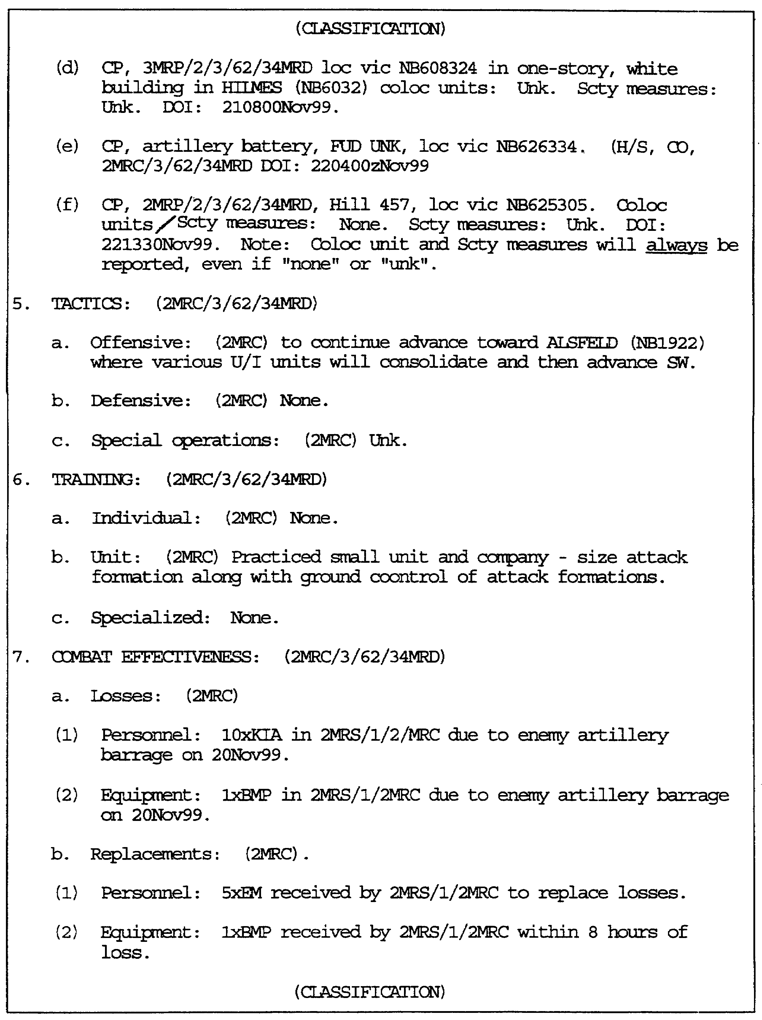

Figure 1-15 (continued).

IT0603 1-28
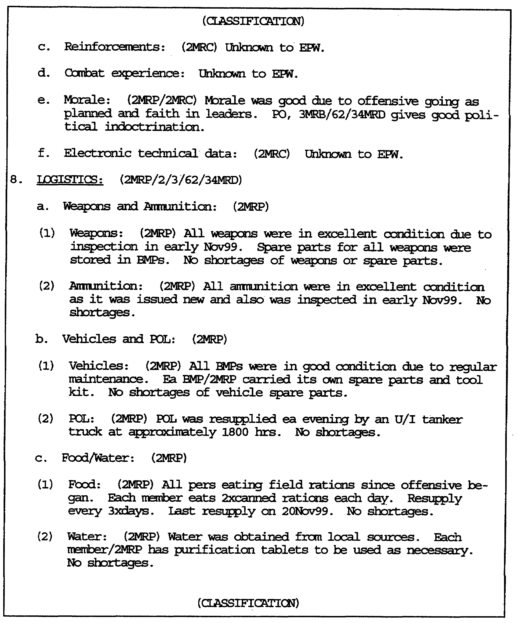

Figure 1-16 (continued).

1-29 IT0603
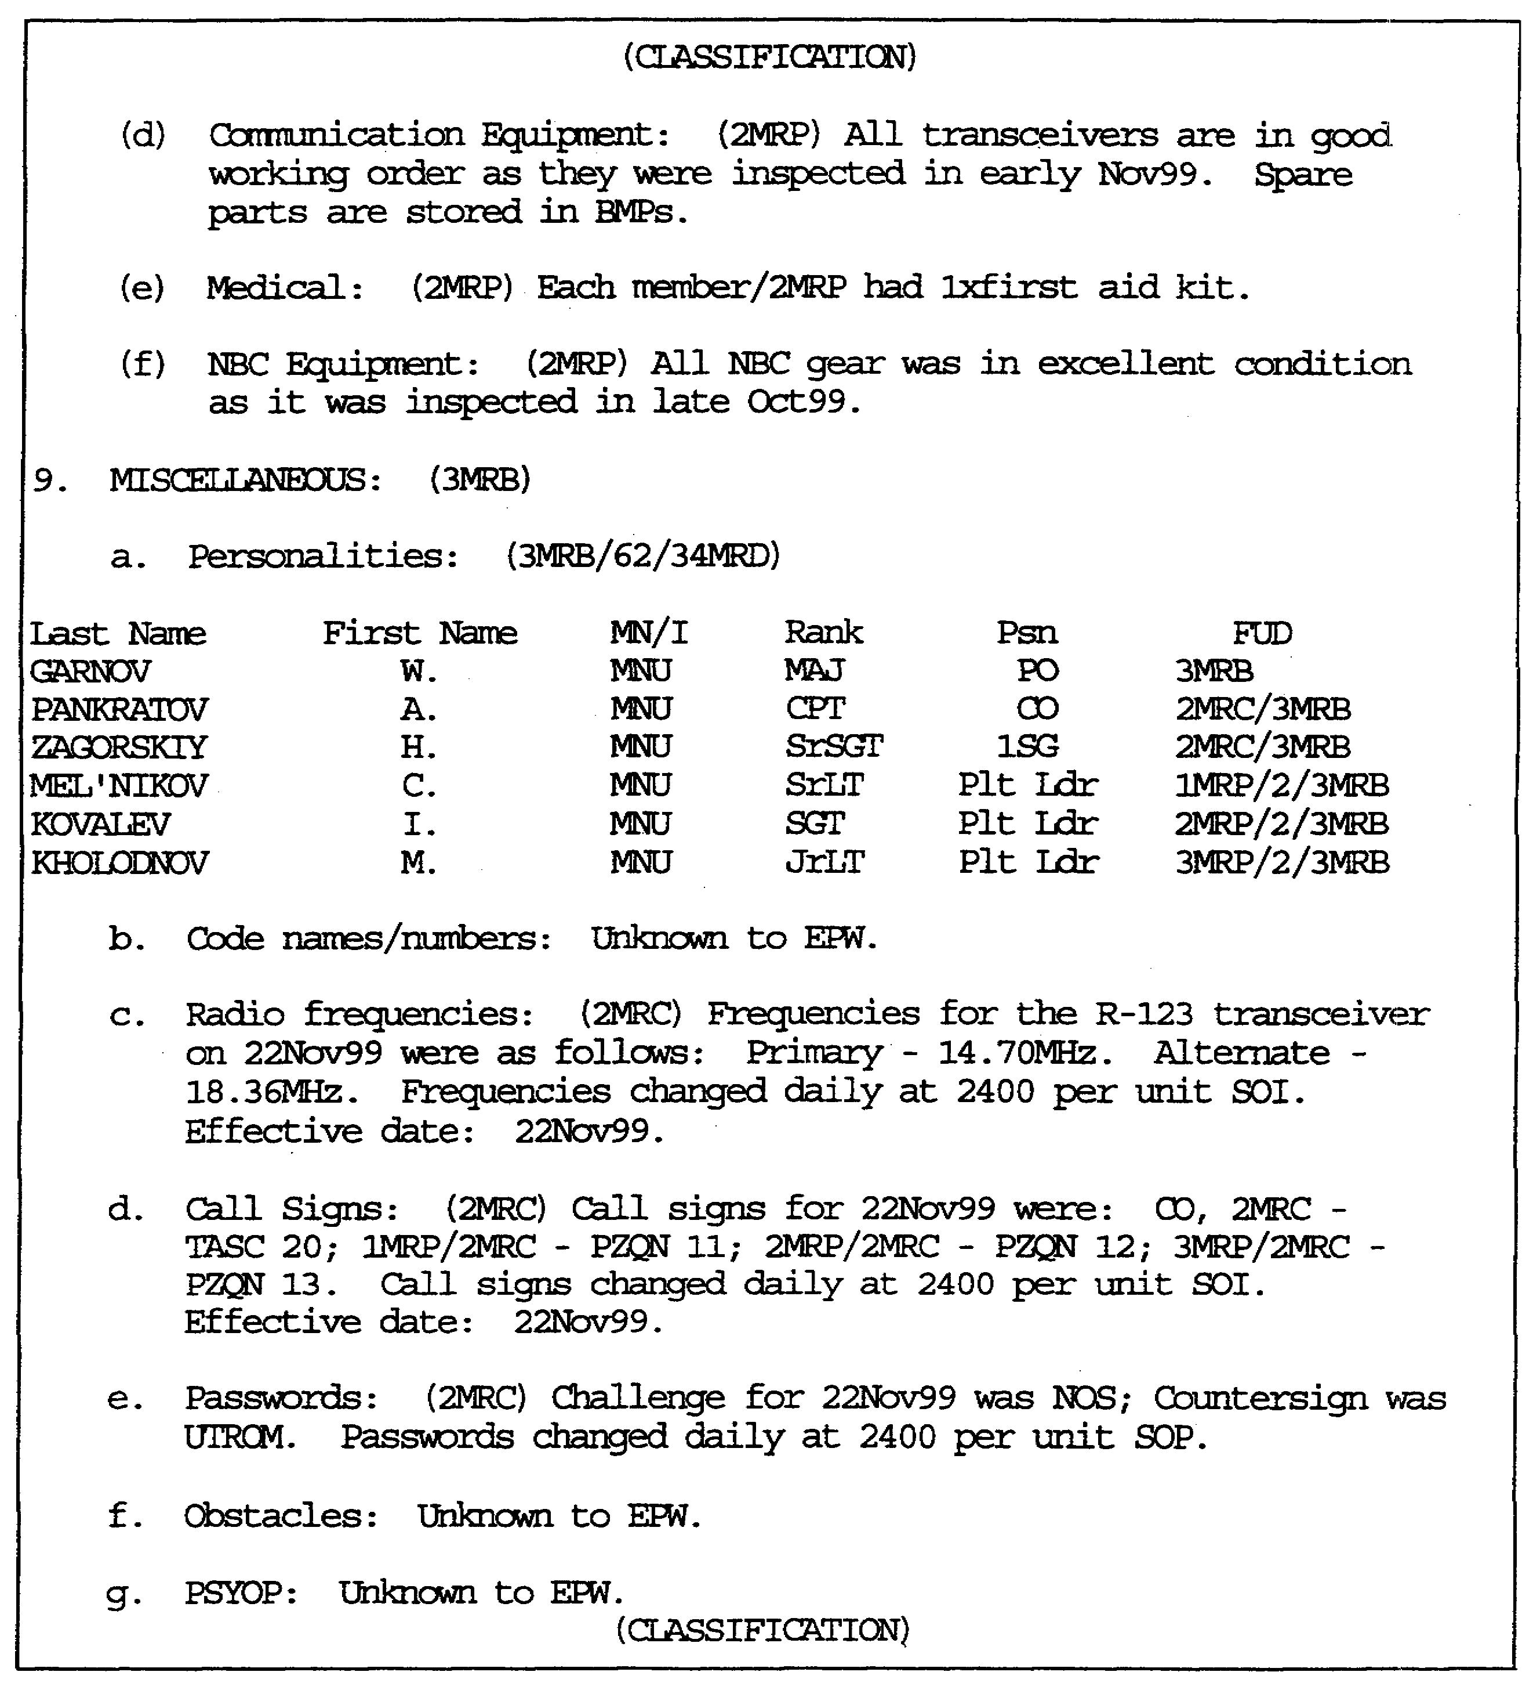

Figure 1-17 (concluded).
CONCLUSION

The preceeding pages have demonstrated how important correct and accurate TIR preparation is to the overall intelligence effort. The interested agency and/or reader can glean vital information pertaining to their requirements and mission. The interrogator must prepare the TIR in a manner so it answers questions, not creates them.

IT0603 1-30
LESSON 1

Practice Exercise

The following items will test your grasp of the material covered in this lesson. There is only one correct answer for each item. When you have completed the exercise, check your answers with the answer key that follows. If you answer any item incorrectly, study again that part of the lesson which contains the portion involved.

1. What is the eighth OB factor listed in a TIR?

A. Dispositions.

B. Weapons and equipment.

C. Miscellaneous.

D. Tactics.

2. A Category D EPW is one who would what?

A. Would satisfy only immediate tactical information.

B. Possesses no intelligence (military) information.

C. Has specific knowledge and must be interrogated without delay.

D. Has information pertaining to the current tactical situation.

3. TIR classification will be done in accordance with what AR?

A. 380-5.

B. 380-6.

C. 385-1.

D. 600-4.

1-31 IT0603
LESSON 1

PRACTICE EXERCISE

ANSWER KEY AND FEEDBACK

Item Correct Answer and Feedback

1. C. Miscellaneous. (Page 1-22).

2. B. Possesses no intelligence (military) information. (Page 1-7).

3. A. AR 380-5. (Page 1-4).

IT0603 1-32
LESSON 2

SPOT REPORTS

CRITICAL TASK: 301-337-1501

OVERVIEW

LESSON DESCRIPTION

In this lesson you will learn to record all spot reportable information completely, accurately, and as quickly as possible without alerting the EPW as to the importance of his information.

TERMINAL LEARNING OBJECTIVE

ACTIONS: Recording and reporting pertinent intelligence information in a correct and readable format.

CONDITIONS: During an ongoing interrogation or while translating captured enemy documents (CED), report intelligence required information in the size, activity, location, unit, time, and equipment (SALUTE) format.

STANDARDS: Record all spot reportable information completely, accurately, and as quickly as possible in the SALUTE format.

REFERENCE: The material contained in this lesson was derived from the following publications:

FM 34-52.

INTRODUCTION

Should an interrogator develop important information during the interrogation, he must determine immediately all essential aspects and ensure the information is reported at, once, before the interrogation is continued. This may require the interrogator to temporarily terminate the interrogation. However, he must avoid alerting the EPW to the importance of the information obtained. For example, should an interrogator learn the enemy plans to launch a counterattack within a few hours, he immediately should determine the unit(s) to participate, the attack's objective, and where and when it will be launched. Further attack details, such as the artillery's role and attack phases, may be developed by continued questioning. Additional items of information obtained, whose intelligence value is dependent upon transmission and use, also should be immediately disseminated to the intelligence officer by means of spot reports.

The interrogation element should retain a written spot report record for future reference. The information rendered by spot reports must

2-1 IT0603
be included in any follow-up reports resulting from an EPWs interrogation. Information may be spot reportable even when an interrogator cannot determine its immediate intelligence value.Spot reportable information is always time-sensitive and answers the supported, higher, or adjacent unit's PIR/IR. Spot reportable information is identified by its potential value. If the information indicates a change in the enemys' capabilities or intentions, it is spot reportable. If an interrogator cannot decide whether or not a piece of information is spot reportable, he should act as though it is. This means he should exploit it fully and record all pertinent information. The interrogator should then consult the senior interrogator for a final determination of the information's value.

A spot report in the SALUTE format (see Figure 2-1) is the vehicle an interrogator uses when disseminating perishable information.

The spot report will be initiated when an EPW has answered all or part of a PIR. The spot report can be disseminated at any echelon and may be written or verbal, normally it is both. The information being reported goes out long before the TIR does. This type of information is reported immediately after receiving it from an EPW. In addition, a hard copy of every spot report will be attached to the TIR prior to its evacuation.

PIR are intelligence requirements that have been identified in the collection mission as being of special interest to the commander and/or are time-sensitive in nature, for example, information that may affect the tactical situation.

Leads are signs which tell an interrogator the EPW has additional pertinent information that can be obtained through further questioning. Leads are provided by an EPWs response to the interrogator's questions.

The understanding of what PIR denote is very important. This understanding will help determine what constitutes a "hot" and "cold" lead.

A cold lead contains information which may not affect the tactical situation. It may be information of immediate intelligence value, but does not need to be immediately exploited. For example, a statement about a unit having a one-day food supply left may be an important lead,-but it does not directly affect the tactical situation, and the information is not time-sensitive in nature. Therefore, the lead is noted and exploited at a later time in the interrogation or in a subsequent interrogation.

Another example of a cold lead might be a statement from the EPW that he was delivering pay to the troops at the hospital. Because the EPW knows the hospital's location, the lead is exploited. This information would probably not be of immediate tactical value, so note the lead and follow up in the topical area of the interrogation in which the information falls. In this case, during dispositions.

IT0603 2-2
Cold leads may expand the interrogation's scope because they may indicate the EPW possesses pertinent information in areas not previously selected for questioning. If the interrogator does not fully exploit all cold leads obtained, he must include information on the leads he did not exploit in his interrogation report.

By comparison, a hot lead is one containing information which could affect the immediate tactical situation in the areas of operations/interest, or affect friendly units operating within an area. Exploit this type of lead immediately, and issue a spot report.

One of the ways to know whether a lead is hot is by determining if it applies to interrogation PIR. A typical PIR list will contain pertinent questions that focus on enemy intentions, such as troop movement, unit strength, weapons, and ammunition.

An example of hot lead pertaining to PIR is: "LT Schwartz told me this morning the 146th MRR is down to 50 percent combat effective strength." This lead could pertain to a PIR which is of vital interest to the commander. Follow-up on this lead for any further information the EPW might have on this subject, and issue a spot report.

A hot lead does not necessarily have to pertain to PIR. For example, if an EPW mentions having heard a bridge was out along a major route near the front, this information would be considered a hot lead because it could directly affect friendly units in the area.

EPW drop leads in direct and indirect ways. Leads may appear while the EPW is telling a story or replying to a question. The interrogator rust exercise caution to ensure the EPW does not deliberately introduce obviously inviting leads as means of evading the topic under exploitation.

The use of follow-up questions to fully exploit hot and cold leads may require an interrogator to cover topics he did not list in his interrogation plan. An interrogator must exploit hot leads as soon as he identifies them. Once the interrogator is sure he has obtained and recorded all the details known to the EPW, he issues a spot report. The interrogator then resumes his questioning at the same point where the hot lead was obtained.

2-3 IT0603
PART A - HEARSAY INFORMATION (H/S)

Hearsay (H/S) information must include the most precise information possible of its source. This will include the person's name, duty position, FUD, and the date time group (DTG) when the EPW obtained the information.

Information not spot reportable will be electronically reported with. A lower priority. These electronic reports will be in the USMTF and submitted according to the procedures established during the senior interrogator's coordination. Copies of spot and interrogation reports pertaining to specific EPW/detainees should accompany them when they are evacuated to the next higher echelon.

Information must be reported accurately according to the following criteria:

- Each information item reported which has a different DOI from the overall report must be accompanied by its correct date.

- Each information item not obtained as a direct result of the EPW/detainee's personal experiences must be accompanied by a description of how he obtained that information.

- All dispositions, towns, and other specific geographic locations must be accompanied by a correct, complete set of at least six-digit Universal Transverse Mercator (UTM) coordinates, to include the correct 100,000 meter grid zone identifier.

- The information is reported exactly as it was obtained from the EPW/detainee. No information is deleted or added without explanatory comments.

- The report contains no errors in spelling, punctuation, or grammar that affect the meaning of the information reported.

As with the TIR, the classification will be written on the top and bottom of each page, front and back. In addition, after the number/letter on each paragraph and sub-paragraph, write the appropriate classification for each particular paragraph and sub-paragraph.

IT0603 2-4
PART B - SPOT REPORT PREPARATION INSTRUCTIONS

Enter the full designation of the unit, office, or agency to which the report will be sent in the "TO" block.

Enter the full designation of the preparer's interrogation element in the "FM" block.

Enter the date on which the report is being prepared in the "DATE" block.

Enter the sequential identification number assigned to the report per local unit SOP in the "REPORT NUMBER" block.

1. SIZE/WHO: Indicate only the size of the unit which is being reported. Example: Battalion-sized unit. Do not indicate the type of unit in this item entry.

2. ACTIVITY/WHAT: This item entry will normally answer PIR related information or, if not, at least the significant mission which is being reported. Example: Bridgehead, Attack, Supply Point, Assembly Area, and so on. The important thing is to keep the "What" simple, limit this entry to those words which will describe what is or will take place (usually one or two word answer).

3. LOCATION/WHERE: This item entry will include the 100,000 meter grid zone designator and a six-digit UTM coordinate of the location where the "What" is to take place. If known, also report a general description of the geographical location in regards to the grid coordinates given. Example: NB123456, along a secondary road, 150m South of the international border.

4. UNIT/WHO: This item will include the FUD of the unit reported. This is the first place to indicate the identification of the unit performing the mission. Use no brevity code and take up to Division, or as far as EPW knows. Look at the FUD of the missions to determine who is doing the mission.

5. TIME/WHEN: The military DIG will be reported here as it pertains to the time the "What" is going to take place. Any indication of time given by EPW will be reported here.

2-5 IT0603
6. EQUIPMENT/HOW: A brief, concise statement concerning the tactic or strategy to be used in accomplishing the "How" of the spot report. Included will be all elements not already explained in the spot report, which will clarify anything about the accomplishment of the "What." Much of this area depends upon the type of follow-up the interrogator used.

7. REMARKS:

a. SOURCE DATA: The EPWs interrogation serial number will be annotated in this block.

b. MAP DATA: This item will reflect the series name, scale, sheet name and the edition of the map used to record any information that may be included in the spot report.

c. H/S: If applicable, H/S information will be reported in this entry using proper H/S format, for example, duty position and FUD of individual from whom the information came, and the DOI.

IT0603 2-6
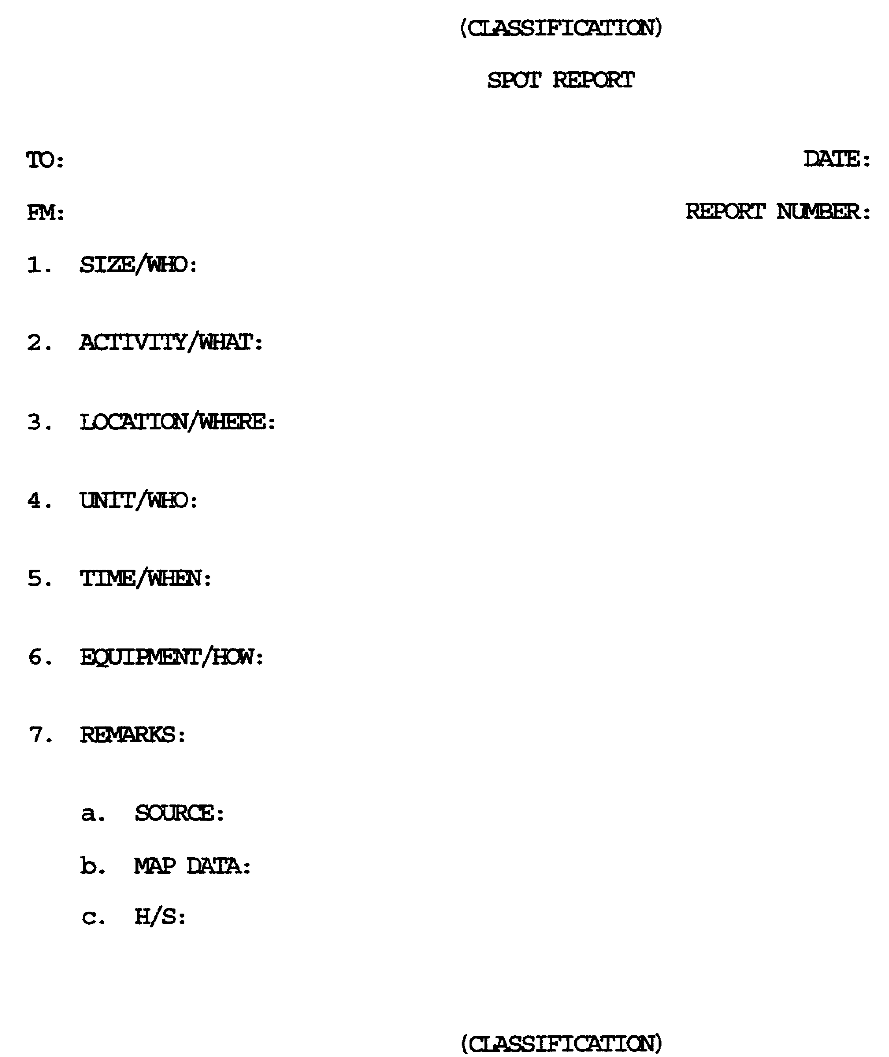

Figure 2-1. Spot Report (blank).

2-7 IT0603
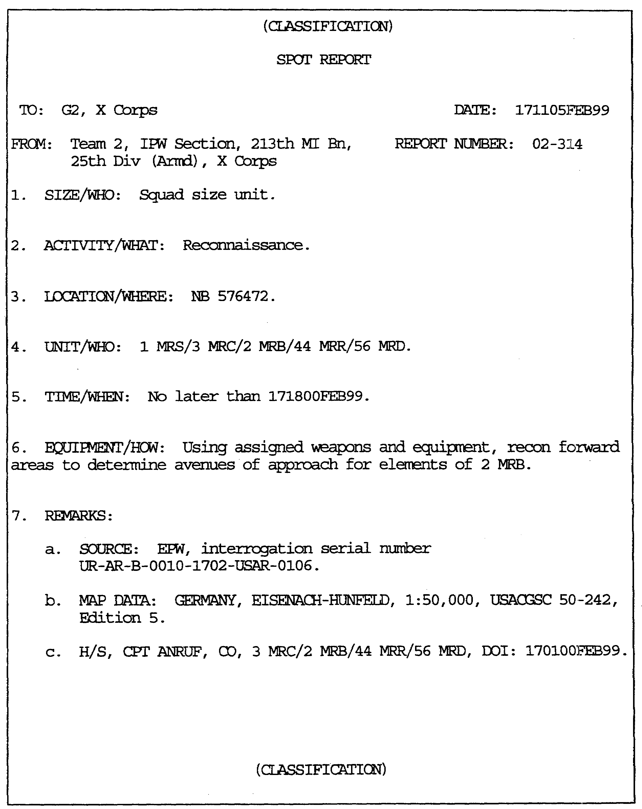

Figure 2-2. Spot Report (Completed).

IT0603 2-8
LESSON 2

Practice Exercise

The following items will text your grasp of the material covered in this lesson. There is only one correct answer for each item. When you have completed the exercise, check your answers with the answer key that follows. If you answer any item incorrectly, study again that part of the lesson which contains the portion involved.

On the next page is an interrogation dialogue which represents the end of the approach and beginning of the questioning phase. NOTE: The interrogation dialogue is an item extract and does not represent a complete interrogation.

Read the extract and identify which item or items the interrogator should spot report, based upon the requirements in the PIR below. Then write a spot report. Use the spot report format on page 2-12.

Priority Intelligence Requirements (PIR)

1. If the enemy plans to attack:

a. When will the attack take place?

b. Where will the main axis of the attack be?

c. What will the frontage and depth of the attack be?

2. What are the current combat effective strengths of units to be committed to the attack?

3. Where are tank and artillery units located?

4. What types and amounts of ammunition are currently being stockpiled? Where?

5. What types and amount of POL are currently being stockpiled? Where?

6. What radio frequencies and call signs are being used by units to be committed to the attack?

2-9 IT0603
INTERROGATION DIALOGUE

I -Interrogator.

E -EPW -SGT DUBOV, Alexi; SN: 1326591, Driver.

I -I told you if you answer my questions, I will make sure you are treated well.

E -I really don't know anything that will help you.

I -I'll be the judge of that. What was your job in your unit before you came over to our side?

E -I'm afraid I'11 get in trouble if anybody finds out I talked to you.

I -Nobody will ever find out what is said in this room. Now what was your job in your unit?

E -I was a BRDM-2 driver.

I -What is your complete unit designation from the highest to the lowest echelon?

E -44th Motorized Rifle Division, 67th Motorized Rifle Regiment, Headquarters Section.

I -What was your mission just before you came over to our side?

E -I dropped the Deputy Regimental Commander off at an artillery forward observer position and, being that close to the front lines, I decided to take the chance of coming over.

I -What was the Deputy Regimental Commander doing at the forward observer (FO) position?

E -I heard him talking with the Regimental Operations Officer, and he said it was their sector and he wanted to become familiar with it.

I -What else did you hear the Deputy Commander and the Operations Officer talking about?

E -It sounded like they were talking about getting the regiment in position for an attack.

IT0603 2-10
I - What other units besides yours are going to take part in the attack?

E - I don’t know.

I - When is the attack to take place?

E - From the way they were talking, it sounded like soon.

I - What else have you heard about the attack?

E - Nothing.

I - Where exactly is the attack to take place?

E - I don't know.

I - What is the rank and last name of the Deputy Regimental Commander?

E - Lieutenant Colonel GLUKHOVSKY.

I - What is Colonel GLUKHOVSKY's first name?

E - I don’t know.

I - What is the name of the operations officer who was talking with Colonel GLUKHOVSKY?

E - He is new. I don't know his name.

I - When did you hear you Deputy Regimental Commander talking about the attack?

E - About 0700 this morning.

END OF DIALOGUE

Assume you are an interrogator with the Interrogation Section, I&S Co, 231st MI Bn in support of the 23d Inf Div (Mech). Address your report to the G2.

NOTE: For map data, use FULDA, 1; 50,000. EPWs interrogation serial number is UR-AR-B-0007-1911-USAR-0012.

When you have written your spot report, turn to page 2-14 to check your answer.

2-11 IT0603
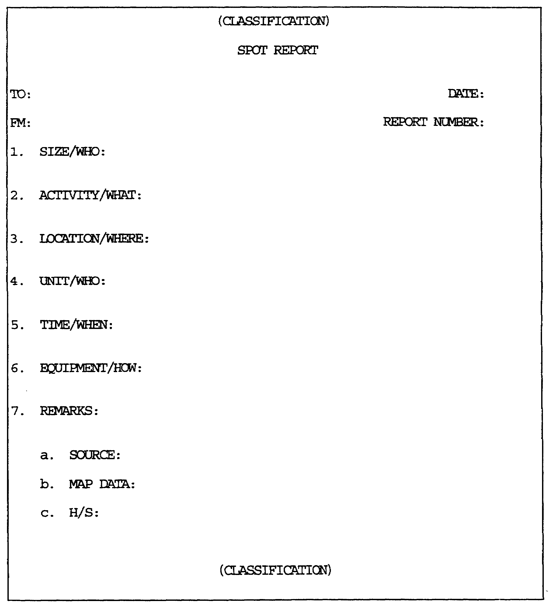

Figure 2-3. Spot Report (Blank).

IT0603 2-12
LESSON 2

PRACTICE EXERCISE

ANSWER KEY

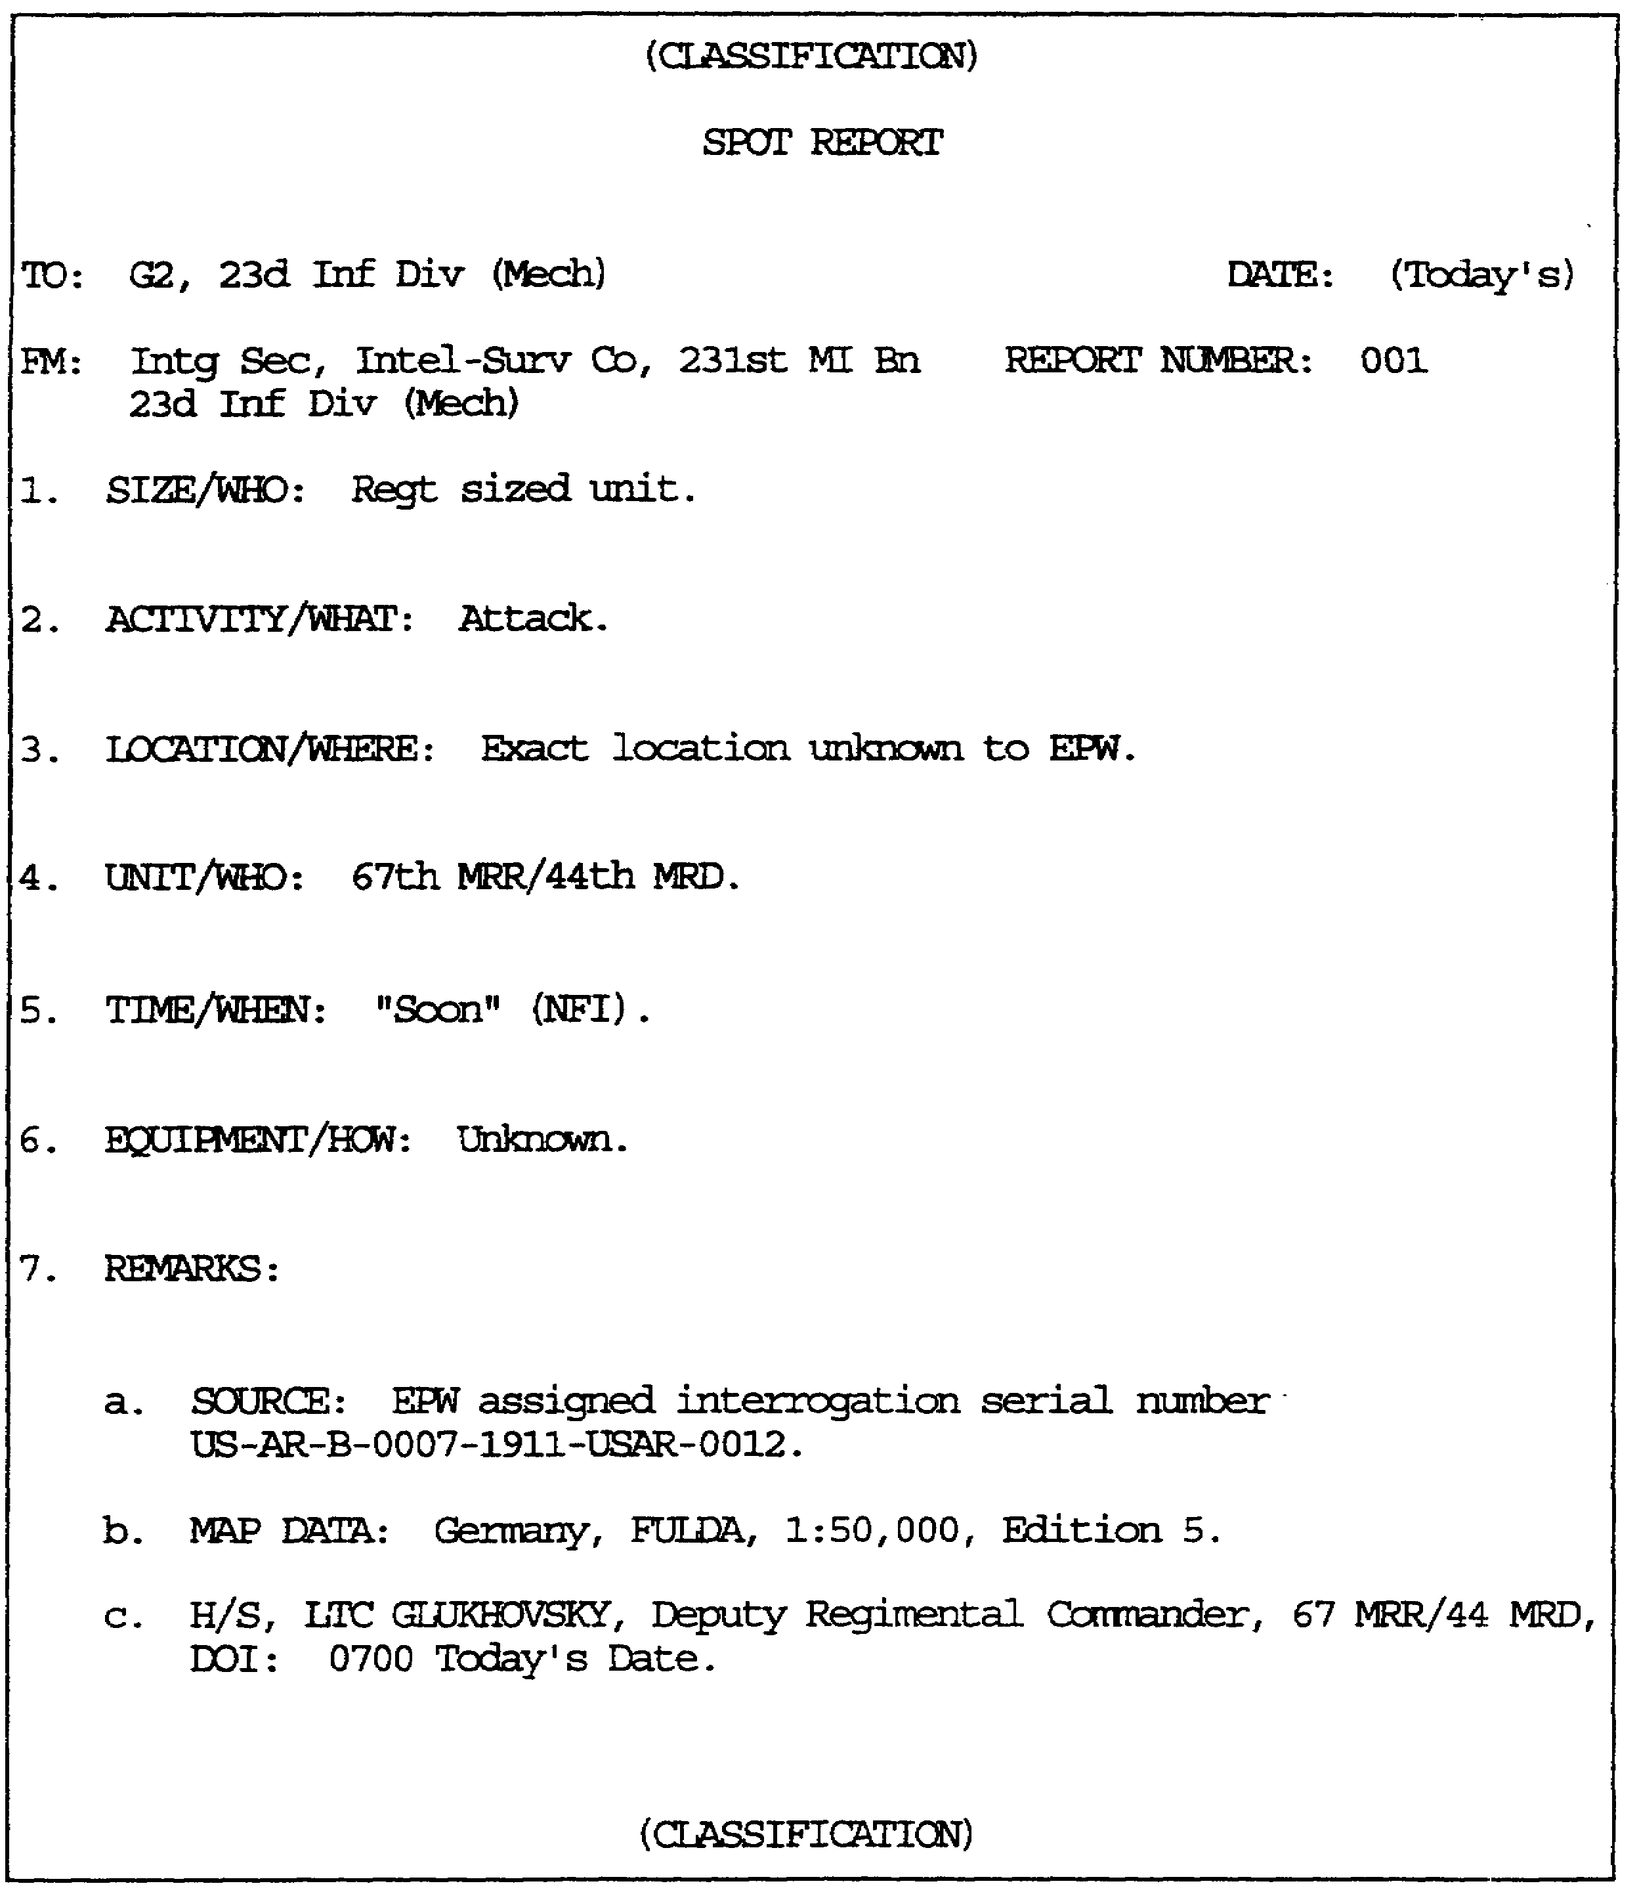

Figure 2-4. Spot Report (completed).

IT0603 2-14
LESSON 3
TRANSLATION REPORTS

CRITICAL TASKS: 301-337-1500/2309

OVERVIEW

LESSON DESCRIPTION

In this lesson you will learn the four document categories, the three types of translations, and how to prepare an error-free translation report.

TERMINAL LEARNING OBJECTIVE

ACTIONS: Record the translation and all relevant information.

CONDITIONS: Know the four document categories, the three types of translations, and correct translation report format.

STANDARDS: Correctly record the translation and all relevant information completely, accurately, and in the correct translation report format.

REFERENCE: The material contained in this lesson was derived from the following publications:

FM 34-52.

INTRODUCTION

A document is defined as any recorded information regardless of its physical form or characteristics.

During combat, a tremendous amount of enemy documents are captured. Intelligence related information derived from these CED can enhance the intelligence effort in gaining valuable information concerning a specific EPW, enemy unit, intentions, or vulnerabilities.

Once a CED has been screened, the main step required for exploitation is to translate it. In order for anyone else to gain benefit from the document, the translation must be recorded in a written format (see Figure 3-1).

A translation report is a written statement of the information gained from a particular document or interrogation. The prime purpose of a translation report is to disseminate intelligence information to interested persons or agencies. At corps and EAC, translation reports are usually distributed as annexes to the periodic intelligence report (PERINTREP).

3-1 IT0603
Proper and accurate translations are incumbent upon the interrogator who is assigned to do the translation.

PART A –DOCUMENT EXPLOITATION (DOCEX)SECTION

Normally, CED enter intelligence channels at brigade level. Although the captured documents may be perused for information at each level, emphasis is placed on processing and evacuating to a higher echelon.

The DOCEX section, usually located at corps (the only exception is a light division), is where the documents will be translated. The original translation will be attached to the original document and a translation file copy will be retained.

Documents to translate care in many shapes and forms. There are three types of documents--personal, official, and identity (for example, ID card/booklet).

Examples of personal documents are:

- Letters.

- Diaries.

- Newspaper.

- Books or magazines.

- Marriage/divorce papers.

- Visas.

- Academic portfolios.

- Family photographs.

Examples of official documents are:

- Overlays.

- Manuals.

- Field orders.

- Maps.

- Plans.

- Codes.

- SOPs.

IT0603 3-2
- Passports.

PART B - TRANSLATIONS

Documents must be screened before translation operations begin in order to establish priorities for the order in which they will be translated. Category A documents will be translated first, technical documents (TECHDOC) contain information pertaining to specific items of captured enemy equipment (CEE), Category B, if assigned to an element that handles them, and then Category C. Category D documents will usually not be translated.

DOCUMENT CATEGORIES

- Category A: Documents containing information of immediate tactical, psychological, or strategic value. Examples of this type of document are those which contain information such as enemy OB, enemy employment of new weapons and. equipment, and the enemy's logistic and morale situation. Information from this type of document will be transmitted to higher, lower, and affected adjacent units by the most expeditious means available.

- Category B: Documents containing cryptographic items and. information concerning enemy radio systems. This category includes such items as encrypted messages, code books and sheets, signal operating instructions (SOI), radio manuals, and so on. These documents require special handling to restrict the number of individuals having knowledge of their capture or content. They will be assigned a classification of SECRET in accordance with AR 380-5. The transmittal cover sheet will state in writing the information is TENTATIVELY MARKED T0 PROTECT IN TRANSIT. The document should remain in intelligence channels and be forwarded as expeditiously as possible to the analysis section located at the analysis and control element (ACE). It is at the ACE where the SIGINT data base is held.

- Category C: Documents containing information of apparent lesser value to intelligence staffs. Examples of this type of document are personal letters, pinup pictures, commercial or business literature, fiction and comic books, and so on. However, it must be remembered the most innocuous appearing documents may contain fragmentary information which, when evaluated in conjunction with intelligence from other sources, may divulge important enemy tactical or strategic intelligence information.

- Category D: Documents containing no information of apparent value to intelligence staffs, but which require special handling. Included are documents the value of which cannot be determined. This category includes such items as oil paintings and money.

3-3 IT0603
There are three types of translation:

o A full translation is one in which the document is translated from one end to the other. It is very manpower- and time-intensive, especially for lengthy or technical documents. It is unlikely many full translations will be done at corps or lower echelons, and, even for Category A documents, it may not always be necessary to translate the entire document.

o An extract translation is one in which only a portion of the document is translated. For instance, a technical intelligence (TECHINT) analyst may decide a few paragraphs in the middle of a 600-page helicopter maintenance manual look interesting, but he does not need a full translation of the manual. He would request an extract translation of the portion of text in which he is interested.

o A summary translation is one in which the translator reads the entire document and summarizes the main points of information, instead of doing a cover-to-cover translation. This type of translation requires more analytical abilities from a translator because he must balance the need for complete document exploitation against the lack of time always present in combat operations. A summary translation may also be done by translators working in languages which they have only limited experience, especially if the language is similar to one already spoken by the translator. For instance, a Russian linguist may not be able to accurately deliver a full translation of a Bulgarian document, but he can probably render a usable summary of the information it contains.

All information resulting from DOCEX activities, including information previously spot reported, will be reported in a translation report. Translation reports are prepared on all Category C CEDs and include portions of Category A, TECHDOCs and Category B CEDs not spot reported.

IT0603 3-4
PART C -TRANSLATION REPORT PROCEDURES:

The translator must ensure his report reflects the following:

- Report destination. Element to which the report will be forwarded.

- Originator. Element where the report was prepared.

- Report number (designated by local SOP).

- Document number (taken from the capture tag).

- Document description consisting of: number of pages, type of document, enemy identification number.

- Original language.

- DIG document was received at the element preparing the report.

- DIG document was captured.

- Document's place of capture.

- Circumstances of document's capture.

- Capturing unit identity.

- Translators' rank and full name.

- Type of translation (full, extract, or summary).

- Remarks for clarification or explanation including an identification of the portions of the document translated in an extract.

- Report is error-free, for example, geographic locations and names are spelled correctly.

- Proper classification markings are placed on the report. Never stamp the classification on the original document, use an appropriate cover sheet.

- Downgrading instructions are correctly entered on the first page of the report in accordance with local SOP.

- Do not mark or deface the original document, for example, underlining or making footnotes.

- Ensure original document is kept separate from other materials which could result in damage, or worse, loss of document.

3-5 IT0603
The names of countries and surnames of persons are written in all CAPITAL letters. In the case where surnames are hard to distinguish, for example, oriental names, CAPITAL letters are used for the entire name. Misspelled or wrongly translated proper names have often led to confusion and erroneous material. The translator must be cognizant of name changes, for example, CHEMNITZ (formerly KARL-MARX-STADT). This could have an impact on the report reader.

Special care must be taken with names of organizations, units, agencies, bureaus, and so on. It is imperative the reader be provided the exact name in the original language to avoid any confusion. Unless the name is widely known in English, the full version of the name in the original language should be given in parenthesis after it is first mentioned.

Abbreviations are unnecessary and only serve to confuse the reader. There are many acronyms and abbreviations inherent to any foreign language, especially the military aspect. Extreme care and caution must be taken by the translator to ensure the reader can follow the text without difficulty.

The translator should never "guesstimate" what the meaning of a word would be. This could be disastrous as it may change the entire connotation of what the document is trying to convey.

The original document is to be protected from damage and no markings may be placed on it. If a document has a classification marking on it, the document will be handled accordingly.

If a document needs to be translated, two copies of the translation report, and the documents' English-language translation, will be prepared. The original report, with the documents' English-language translation attached, are immediately evacuated directly to the supported command's intelligence officer. The other translation report copy, with English-language translation of the documents' contents, are returned with the original document and its capture tag to the military police for evacuation.

NOTE: Due to limited filing space for an interrogation unit at tactical echelons, no file copy is kept.

When translating document contents, the interrogator should only report the direct English-language translation, and should refrain from analyzing the contents. What may seem unimportant to the interrogator doing the translating, may be very important to the OB analyst who has additional information/intelligence to compare it with.

Through the use of notes, the interrogator may insert comments/ recommendations at the end of the English-language translation to augment the translation.

IT0603 3-6
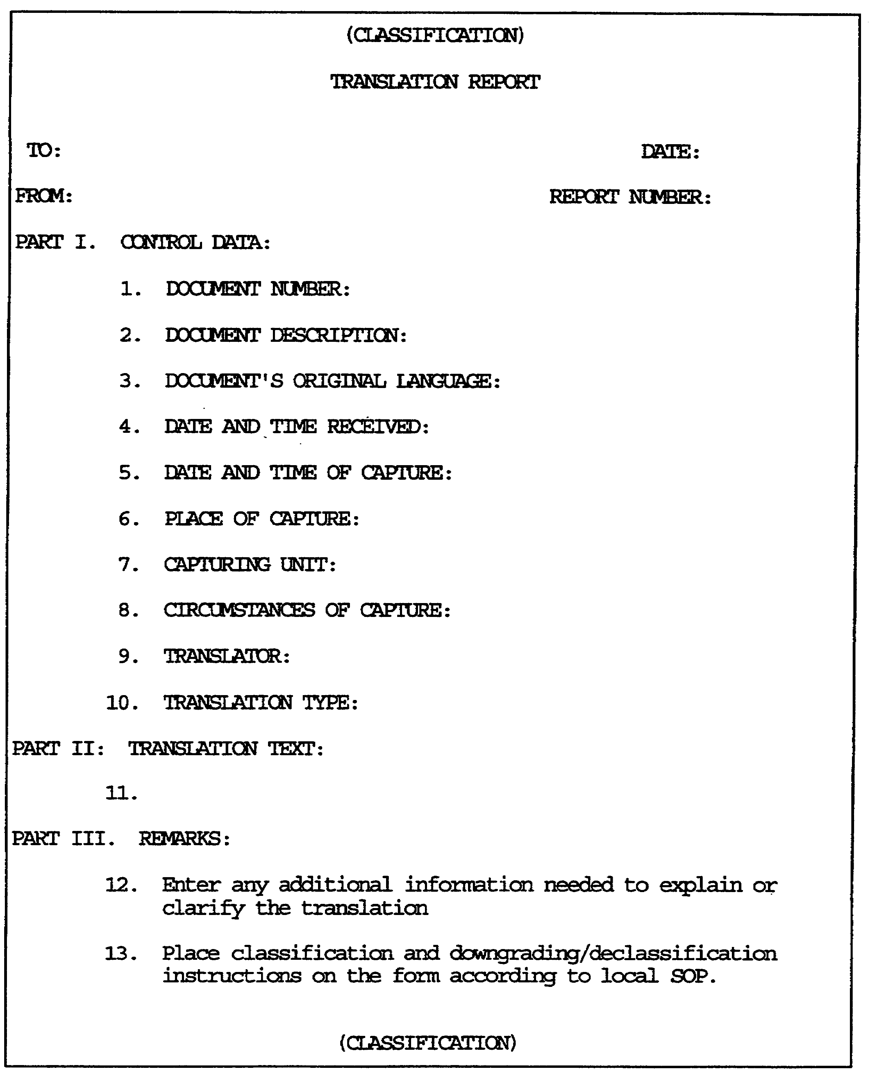

Figure 3-1. Translation Report (Blank).

3-7 IT0603
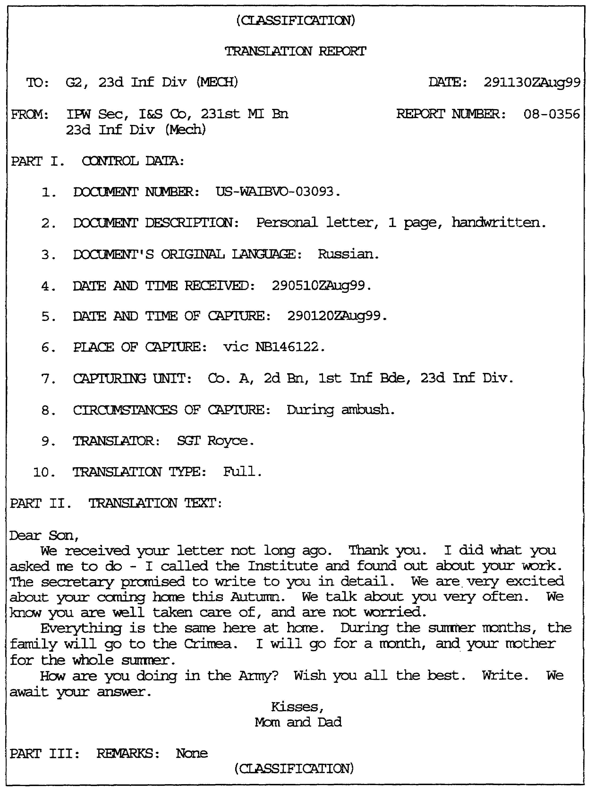

Figure 3-2. Translation Report (Completed).

IT0603 3-8
LESSON 3

Practice Exercise

The following items will test your grasp of the material covered in this lesson. There is only one correct answer for each item. When you have completed the exercise, check your answers with the answer key that follows. If you answer any item incorrectly, study again that part of the lesson which contains the portion involved.

1. Category A documents contain information of what intelligence value?

A. Cryptologic value.

B. No intelligence value.

C. Apparent lesser intelligence value.

D. Immediate tactical value.

2. An example of an official document is what?

A. Map.

B. Diary.

C. Letter.

D. Newspaper.

3. A document is defined as what?

A. Anything which was in enemy possession.

B. Anything with a security classification.

C. Any recorded information regardless of its physical form or characteristics.

D. Anything pertaining to the current tactical situation.

3-9 IT0603
LESSON 3

PRACTICE EXERCISE

ANSWER KEY AND FEEDBACK

Item Correct Answer and Feedback

1. D. Immediate tactical value. (Page 3-3).

2. A. Map. (Page 3-2).

3. C. Any recorded information regardless of its physical. form or characteristics. (Page 3-1).

IT0603 3-10

